Integrating GraphQL with Next.js for Efficient Data Fetching and Advanced React Techniques

S VIGNESH

Final Thesis Report

December 2024

# DEDICATION

This Final Thesis Report is dedicated to all those who have inspired and supported me on this journey. To my family, whose unwavering love and encouragement have been my anchor through the highs and lows of this endeavour. To my friends and mentors, whose guidance and wisdom have enriched my understanding and fuelled my passion for research. And to all the individuals who have shared their knowledge and expertise, shaping the path of this project. Your belief in me has been a driving force, and I dedicate this work to each of you with heartfelt appreciation.

# ACKNOWLEDGEMENT

I would want to use this chance to personally thank everyone who has helped to see my thesis successfully completed. I owe a great deal of thanks to Dr. Prakash G for his helpful direction, insightful comments, and unwavering support over the whole research process as an Associate Professor in the Department of Computer Science and Engineering at the VIT in Vellore.

Along with that, I would want to thank Liverpool John Moores University, which is situated in Liverpool, United Kingdom, and UpGrad Education, which is based in India, for offering the essential tools, academic support, and appropriate learning environment required for the successful completion of this research.

All of which have really helped to raise the caliber of this work, I would want to especially thank my colleagues and peers for their intelligent dialogues, support, and cooperative attitude.

Finally, I would want to sincerely thank you to my family and friends for their unshakable support, patience, and encouragement; they have been a regular source of inspiration on this challenging but rewarding road.

# ABSTRACT

Integrating GraphQL with Next.js is a flexible solution for improving the speed of data loading and utilizing complex React features in today's web projects. Next.js's versatile and optimized features for serving static/dynamic pages complement GraphQL with flexible and precise data querying features. Having adopted Next.js's strong and powerful fundamentals of what is known as server-side rendering (SSR) and static site generation (SSG), developers can work on optimum performance and user interfaces.

This integration promotes better management of data as it reduces cases of over-fetching while at the same time keeping response times low. Next.js primarily has integrated support for incremental static regeneration, while GraphQL enables querying only the necessary data, so the UI can be updated without a negative impact on speed(Bui and Mynttinen, 2023). Moreover, when using sophisticated elements of the React framework such as Suspense and Lazy Loading with the help of GraphQL integration, developers can guarantee a seamless user experience and fast page loading times.

This research aims to find out how Next.js can benefit from GraphQL and vice versa, as well as the difficulties that may be encountered in the process. It seeks to establish specific recommendations for updating the mechanisms for loading data, as well as improvements in web application architecture with reference to performance, SEO, and UX.

# LIST OF TABLES

Table 1 Comparative Analysis Of Related Studies 48

Table 2 Jest Test Results And Coverage 64

# LIST OF FIGURES

Figure 1 Architecture for Integrating GraphQL with Next.js via Apollo Federation 12

Figure 2 Multi-Layered Architecture Diagram 56

Figure 3 Lazy Loading & Suspense Code Snippet 57

Figure 4 NodeJs with Apollo Server Code Snippet 57

Figure 5 JWT Authentication Code Snippet 58

Figure 6 WebSocket Subscriber Code Snippet 59

Figure 7 Snapshot of the OWASP ZAP automated vulnerability scan. It highlights key detected issues, including insecure headers and potential injection points in GraphQL endpoints, aiding in strengthening application security. 61

Figure 8 GraphQL Code Snippet 62

Figure 9 Prometheus Configuration Snippet 63

Figure 10 An example Grafana configuration used to visualize real-time system metrics like API latency, server resource usage, and error rates. Enables proactive performance monitoring and alerting. 64

Figure 11 Monitoring GraphQL Mutation Rates Using Grafana 68

Figure 12 Monitoring GraphQL Query Rates Using Grafana 68

Figure 13 OWASP ZAP Active Scan Result Interface 70

Figure 14 Findings from OWASP ZAP Scans 70

Figure 15 Security Fix Code Snippet 70

Figure 16 A representative example of a Jest test validating a GraphQL API response. This snippet demonstrates unit-level validation of user authentication and response structure, showcasing test-driven development in action. 71

Figure 17 Patient/Doctor New Registration API Workflow 73

Figure 18 Patient/Doctor Login API Workflow 74

Figure 19 Depicts the complete API interaction flow for retrieving prescription details. Includes input validation, secure data fetching, and JSON response structure tailored for healthcare records. 75

Figure 20 Get Appointment by Date Filter API Workflow 76

Figure 21 Get Specialization for Doctor Registration API Workflow 77

Figure 22 Get List of Available Doctor in Patient Dashboard for Booking Appointment API Workflow 78

Figure 23 Patient/Doctor Registration Page 79

Figure 24Patient/ Doctor Login Page 80

Figure 25 Patient Dashboard Page 81

Figure 26 Prescription Details Modal 82

Figure 27 Update Appointment Modal 83

# TABLE OF CONTENTS

DEDICATION 2

ACKNOWLEDGEMENT 3

ABSTRACT 4

LIST OF TABLES 5

LIST OF FIGURES 6

TABLE OF CONTENTS 8

CHAPTER 1: INTRODUCTION 12

1.1 Background 12

1.2 Understanding GraphQL 12

1.3 More than a simple React tool 12

1.4 Advanced React Patterns for User Experience 12

1.5 The Power of Combining Next.js with GraphQL 13

1.6 Boosting Performance and SEO 13

1.7 Problem Statement 14

1.8 Related Research 14

1.9 Research Questions 15

1.10 Aim and Objectives 16

1.11 Significance of the Study 16

1.12 Scope of the Study 17

1.13 Summary 18

CHAPTER 2: LITERATURE REVIEW 19

2.1 Introduction 19

2.2 Data Fetching Efficiency with GraphQL 20

2.2.1 The Adaptable Query Language of GraphQL 20

2.2.2 Data Retrieval in Serverless Architectures 21

2.3 Challenges in Large-Scale Data Retrieval 22

2.3.1 Query Complexity and Optimization 24

2.3.2 N+1 Query Problem 26

2.3.3 Resource Allocation in Large Queries 30

2.3.4 Database Bottlenecks 34

2.3.5 Monitoring and Analytics in GraphQL Systems 38

2.4 Advanced React Techniques for Better UX in Architectural Services 44

2.4.1 The Adaptable Query Language of GraphQL 44

2.4.2 Lazy Loading for Architectural Web Applications 44

2.4.3 State Management Challenges in Architectural Systems 45

2.4.4 Integration with AI and BIM Platforms 46

2.5 Security Concerns in GraphQL-Next.js Integration 46

2.5.1 Common Vulnerabilities 46

2.5.2 Best Practices for Security 47

2.5.3 Real-Time Data Security 47

2.6 Real-world Applications of GraphQL with Next.js 48

2.6.1 E-commerce Platforms 48

2.6.2 Content-Heavy Platforms 48

2.6.3 Healthcare Applications 48

2.7 Comparative Analysis of Related Studies 49

2.8 Research Gaps 49

2.9 Summary 49

CHAPTER 3: RESEARCH METHODOLOGY 50

3.1 Introduction 50

3.2 Methodology 50

3.2.1 Data Selection and Collection 50

3.2.2 Data Pre-processing 51

3.2.3 Experiment Design 52

3.2.4 Tools and Technologies 52

3.2.5 Evaluation Metrics 55

3.2.6 Validation and Analysis 55

3.3 Summary 56

CHAPTER 4: IMPLEMENTATION 57

4.1 Introduction 57

4.2 Architecture 57

4.3 Frameworks and Technologies Used 58

4.3.1 Frontend 58

4.3.2 Backend 59

4.3.4 Authentication 60

4.3.4 Real-time Updates 60

4.3.5 State Management 61

4.3.6 Monitoring Tools 61

4.3.7 Testing Frameworks 62

4.4 Implementation Steps 63

4.5 Summary 66

CHAPTER 5: RESULTS AND EVALUATION 67

5.1 Introduction 67

5.2 Performance Evaluation 68

5.3 Security Assessment 71

5.3 Test Results and Coverage 73

5.4 API and UI Screenshots 74

5.5 Usability Testing (UAT) 86

5.6 Summary 86

CHAPTER 6: CONCLUSIONS AND RECOMMENDATIONS 87

6.1 Introduction 87

6.2 Discussion and Conclusion 87

6.3 Recommendations 89

6.4 Future Work 90

6.5 Summary 91

APPENDIX A: Research Proposal 97

APPENDIX B: Integration of GraphQL with Next.js in Healthcare Application 97

APPENDIX C: Code for Implementation 97

APPENDIX D: OWASP ZAP Scanning Report 97

APPENDIX E: Code for Testing 97

# CHAPTER 1: INTRODUCTION

## 1.1 Background

This research introduces the integration of GraphQL with Next.js, emphasizing core features that facilitate the development of modern, high-performance web applications using React. Both technologies provide efficient and flexible tools, significantly streamlining data fetching processes and frontend rendering.

## 1.2 Understanding GraphQL

GraphQL is more than a new tool, it feels like an entirely different paradigm for how to think about data in our web apps. Facebook rolled out GraphQL back in 2015, to exceed the functionality required by a vast majority of applications because data is hard to use. If you think REST APIs then more commonly endpoints and calls, with one call compared to multiple, our request for data is simplified by GraphQL(Zanevych, 2024). This may especially be useful for applications that need to communicate data in the backend and frontend of any sort even simpler or complex ones.

## 1.3 More than a simple React tool

Next.js has a powerful toolset to build web pages, not only React(Fariz et al., 2022). Enjoy server-side rendering or static site generation and more without the headache(Hung Le, 2023). All these features make Next.js a great alternative to creating fast, SEO-friendly and user-optimized apps. It can be tailored to how the page is displayed, whether as a dynamic site or traditional static pages meshed work nicely with divergent needs in mind. And in today's digital world where everything moves fast, this flexibility is not just a bonus but its basic requirement(Bhamare et al., 2023).

## 1.4 Advanced React Patterns for User Experience

React is a powerful library on its own, however it can do all the magic to create an awesome user experience if used with some additional advanced features. Having control of how components load by using techniques like React Suspense and Lazy Loading means users also benefit from seamless user interactions(Desamsetti and Dekkati, 2021). With React Suspense you will get loading screens for our data or components while it is being queried, avoiding blank pages. That literally means, components will only be loaded when required, this makes our app more efficient. Beyond speed, these techniques make the app feel responsive and smooth to use.

## 1.5 The Power of Combining Next.js with GraphQL

Using GraphQL with Next.js merges two powerful tools. This allows you to request data that only you need, making the API more efficient as it removes server calls(Santosa et al., 2023). Next.js then plugs that data into the optimal method through server, client or static HTML output. This combination makes our web app very smart and fast responsive in all the ways, that help users for getting immediate results without any delays. The research will establish an understanding of how these technologies work in conjunction and evaluate the pros, cons, challenges faced and approaches a developer can take to optimize usage together(Thang Nguyen, 2022).

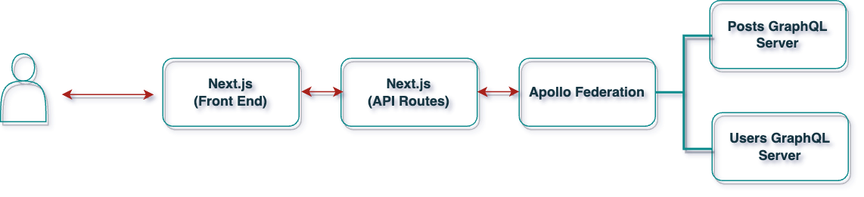

Figure 1 Architecture for Integrating GraphQL with Next.js via Apollo Federation

## 1.6 Boosting Performance and SEO

Both GraphQL and Next.js is dramatically increasing the performance and SEO notes for web applications. Opting for selective data fetching in GraphQL helps to lower loading times, and as well ensures you retain our users which is good news with respect to browser ranking for every little detail that contributes here(Bhamare et al., 2023). Next.js also helps SEO by server-side rendering to make our content friendly with search engines. It also helps in reducing the JavaScript payload resulting is a faster application, which is useful on slower networks. Better performance and SEO are important to increase the user experience as well as be ranked higher on searches(Vishal Patel, 2023).

## 1.7 Problem Statement

In today's fast-paced web development industry, developing websites and applications that are not only swift and scalable, but also simple to use, is more crucial than ever. Traditional solutions, such as REST APIs and simple client-side rendering, are beginning to fail, particularly when it comes to handling complicated, high-traffic websites(Mikuła and Dzieńkowski, 2020). That’s where modern tools like Next.js and GraphQL come in. They offer powerful solutions but bringing them together isn’t always straightforward. Developers face challenges like making sure the site is fast while balancing server-side and client-side work, keeping the app’s state consistent, and making sure data is fetched efficiently. Plus, there’s the ongoing task of improving things like how quickly the site responds to users and how well it performs in search engines.

This research focuses on how combining Next.js and GraphQL can help solve these challenges. The goal is to provide clear, actionable advice for developers on how to make the most of these tools, while also pointing out any potential issues that might come up during their integration(Yunita, 2023).

## 1.8 Related Research

There has been a lot of work done to understand how Next.js and GraphQL can be used effectively, both on their own and together:

*1. GraphQL for Smarter Data Management*

I tried to find out the reasons why GraphQL makes developers life easier and found a few studies show that unlike rest API(Niswar et al., 2024), with GrahpQL using query language we can get or even demand (in some cases) only necessary data preventing from getting extra fields (if not requested) or missing ones if response does not contain important keys already(Desamsetti and Dekkati, 2021). While more exact matches can result in better performance, it can also increase the load on the server's CPU especially during high traffic periods.

*2. Next.js for Speed and SEO*

One of the advantages of Next.js is that it can make web pages faster, and specifically on server-side rendering or static site generation(Vishal Patel, 2023). These characteristics mean pages load more quickly and are easier to be crawled by search engines, so that the site would get increased traffic as a result. There are other techniques however such as splitting code into smaller chunks or using image optimization that also lead to performant websites(Bhamare et al., 2023).

*3. Bringing GraphQL and Next.js*

Each of these tools has its strengths and there will always be use cases where npm scripts are preferred (or even the only option) but using them together, although a bit challenging sometimes, can also make for really rewarding configuration. Combining the two appears to help make web applications both more responsive and easier to scale, at least according to early research(Mikuła and Dzieńkowski, 2020). But introducing this state(Patil and Dhananjayamurty Javagal, 2022) also adds new problems, you want to keep the data consistent between server and client, manage real-time updates cleanly, make sure everything stays secure (both in-flight and at-rest).

## 1.9 Research Questions

Even though there’s been a lot of progress in understanding how to use Next.js and GraphQL, there are still some important areas that need more exploration(Paulsson, n.d.).

This study helps us to address these gaps by providing a detailed analysis of how Next.js and GraphQL can make fast scalable secure web applications. This will serve as actionable information for developers and expand the boundaries of what is possible with modern web development.

*RQ 1: How can GraphQL be integrated with Next.js to achieve efficient data fetching while ensuring optimal use of both server and client resources?*

*RQ 2: What are the best ways to keep state consistent between server-side and client-side rendering when using Next.js and GraphQL together?*

*RQ 3: How does integrating Next.js & GraphQL speed up, reduce CPU load and improve SEO for high-traffic websites?*

*RQ 4: Identify best practices in securing GraphQL APIs when we implement them with a Next.js world, especially those that handle real time data?*

*RQ 5: How do real-world implementations of Next.js and GraphQL compare in terms of scalability and performance, and what lessons can be drawn from these examples to guide future development?*

## 1.10 Aim and Objectives

This research project seeks to investigate methods for making the integration between GraphQL and Next.js more efficient, to enhance the performance of web applications in general, and to utilize more advanced features of React to build speedy, scalable and user-friendly websites.

To achieve this goal, this project will have the following objectives:

* To know the grip of GraphQL and Next.js if used correctly, can help us fetch data in highly optimized way and uses server-side resources as well client-side resources.
* To create strategies for preserving application state seamlessly during server-side rendering and client-side rendering with Next.js and GraphQL.
* To assess the effect of this interaction between GraphQL with Next.js on performance issues of interest, such as response time, CPU usage, SEO etc. while utilizing the program in high-volume circumstances.
* To provide best practices for securely leveraging GraphQL APIs in a Next.js environment, particularly for apps that serve real-time data.
* To examine use cases that focused on integrating Next.js with GraphQL, assess their success or failure, and analyze the consequences for web development in future projects.

## 1.11 Significance of the Study

This study is essential because it addresses some of the most serious issues in modern web development, providing answers that could have a genuine impact on developers and end users alike. By combining GraphQL and Next.js, the study hopes to achieve new levels of efficiency, security, and user experience that are critical in today's fast-paced digital world.

* *Enhancing Web Performance in The Real World*: Hundreds of milliseconds can be the difference between good and bad web applications; therefore, speeding up data retrieval or better resource consumption could change them(Bang Nguyen, 2021). This study explores how a blend of GraphQL and Next.js can inevitably lead to quicker, more sensitive webpages that maintain users interested or contented in extreme traffic periods.
* *Making SEO Work Smarter, Not Harder:* SEO isn’t just about keywords anymore; it’s about how well our website performs under the hood. By exploring how Next.js’s server-side rendering and static site generation can work together with GraphQL’s efficient data querying, this research could lead to websites that not only perform better but also rank higher on search engines. It leads to added visibility, increased organic footfall and at the end of it all more profitability.
* *Reliable Security frameworks:* Today, we live in an era when data breaches have become quite frequent so maintaining the security of web apps is more paramount than ever. This research will be very specific, to care about a right way to secure GraphQL APIs for an environment like Next.js where we deal with apps that use real-time data. Developers can leverage this intelligence to shrink attack surfaces, allowing for developers to develop more trustworthy and safe web applications that protect users and their data from invasions of privacy.

## 1.12 Scope of the Study

This research will explore how GraphQL can be integrated into Next.js to improve the performance, security and experience of web applications. The research looks at real-world cases where these technologies shine the best, namely: high-traffic websites that need fast data fetching with high levels of security(Hung Le, 2023).

In this research, we will see how to combo with a Graphql and Next.js while working on advanced React techniques like Suspense based Lazy Loading for the great user interaction as well using other avenues which can improve our page First Load(PFL) time. This will also touch upon the implications of this integration in terms of SEO, especially where visibility and search for ranking are concerned server-side rendering & static site generation is a must.

But again, this research looks at using Next.js and GraphQL together for scalable high performance webapps. This will overlap a bit with my other research into similar technologies but generally, it is about how GraphQL and Next.js work together to support different features. No other web development frameworks or ways of querying data will be accounted for in the study, besides GraphQL.

Although this research will be based on real-world examples to help businesses know what can work for them, it would not examine all use cases and specifics like how each industry sails in such a scenario. These are meant for general best practices and guidelines that can be applied to a various context, not an exhaustive dive on all possible applications.

## 1.13 Summary

This chapter sets the stage for the research by explaining the motivation behind integrating GraphQL with Next.js to build high-performance, scalable web applications. It introduces key concepts like server-side rendering, data fetching efficiency, and real-time updates, emphasizing how modern React techniques like Suspense and Lazy Loading can improve user experience. The chapter also defines the research problem, lays out the research questions, and outlines the study's objectives, scope, and significance—especially in industries like healthcare where speed and security are critical.

# CHAPTER 2: LITERATURE REVIEW

## 2.1 Introduction

GraphQL integration with Next.js has exploded in modern web development as of late, given the convenience of simplifying data fetching, scalability, and generally better application performance. Integrating GraphQL's strong features of precise querying with the capability of Next.js features, such as Server-Side Rendering (SSR) and Static Site Generation (SSG), enables developers to build efficient, responsive, and SEO-friendly applications.This chapter looks at the study and real-world knowledge that has already been done on GraphQL, Next.js, and combining them. All of this will be covered, from the academic background to how it is used in the real world, including ways to improve performance, safety measures, and case studies.

When Facebook launched GraphQL in 2015, it changed the way data is retrieved from APIs in a big way.With GraphQL, developers can only ask for the info they need. A normal REST API will often get too much or too little info. This is not the same. The size and effectiveness of the payload have a direct effect on how well web and mobile apps work and how satisfied their users are with them. This targeted way works especially well for these types of apps.

Meanwhile, Next.js further develops the React foundation to offer advanced rendering strategies like SSR, SSG, and Incremental Static Regeneration (ISR). SSR is used for pre-rendering pages on the server. It has greatly improved TTFP, which also results in good SEO performance. SSG will generate static pages at build time; this results in lightning-fast load times with reduced server overhead. The ISR blends both benefits so that developers can update specific content without redeploying the entire application.

GraphQL and Next.js form a dynamic duo when used together. GraphQL simplifies the queries of backend data, and Next.js keeps the frontend performant and SEO-optimized. This combination reduces latency, enhances scalability, and manages resources in an efficient manner across the stack.

These studies have shown, time and again, the benefits of integration. For example, Jin et al. (2024) demonstrated how GraphQL can better serve cold-start scenarios over REST APIs, especially in serverless architecture. Patel and Javagal (2022) demonstrated how Next.js SSR enables better SEO and performance on content-heavy websites, with pre-rendering on the server.

However, this integration is not without its challenges. Challenges such as managing state across server-side and client-side rendering, query optimization in large-scale applications, and securing GraphQL endpoints continue to surface. While tools like Apollo Client and Relay provide partial solutions, they still have limitations, especially when deployed at scale.

This chapter shall focus on such challenges and address them in detail with important architectural patterns, optimization techniques, and robust security strategies. The real case studies from the domains of e-commerce, content management systems, and healthcare applications are studied to bring out actionable insights.

We will also discuss some of the prominent research gaps, such as state management consistency, performance bottlenecks in complex deployments, and security vulnerabilities that remain unsolved. By integrating academic findings with industry best practices, this literature review aims to provide a comprehensive guide to successfully integrating GraphQL with Next.js.

The subsequent sections will take a further detailed view into aspects like the efficiency of data fetching, real-time synchronization, rendering strategy, advanced React techniques, and security considerations-all brought into practice with case studies taken from the implementation in actual projects.

## 2.2 Data Fetching Efficiency with GraphQL

### 2.2.1 The Adaptable Query Language of GraphQL

GraphQL, introduced by Facebook in 2015, was designed to address the inefficiencies of REST APIs. Zanevych (2024) emphasizes that GraphQL enables clients to request only the data they need, reducing over-fetching and under-fetching issues. This feature is particularly beneficial for mobile applications and low-bandwidth networks. GraphQL provides a declarative approach to data fetching, allowing clients to specify their exact data requirements in a single query. This contrasts sharply with RESTful APIs, where multiple endpoints are often needed to retrieve related data entities. Studies by Guha (2020) highlight how GraphQL reduces latency in complex data retrieval scenarios, particularly in microservices architectures. Research conducted by Jin et al. (2023) further explores how query complexity and response times are affected by large-scale datasets. The study emphasizes that optimized query planning and proper schema design can mitigate latency issues and ensure efficient data transmission.

Additionally, Keller and Lee (2023) identified key schema design patterns for GraphQL that balance flexibility and performance, highlighting the role of query batching and schema stitching in optimizing data delivery (Keller & Lee, 2023).

### 2.2.2 Data Retrieval in Serverless Architectures

The study by Jin et al. (2024) examined GraphQL and REST within serverless environments. The findings indicated that GraphQL could facilitate information retrieval and reduce network latency. Research indicates that serverless GraphQL endpoints outperform REST APIs in scenarios including cold starts, where latency surges are prevalent. The single-endpoint methodology of GraphQL aids serverless architectures by reducing API Gateway overhead and optimizing resource utilization. Jin et al. discovered that GraphQL is effective in distributed systems and serverless applications requiring access to dynamic data.

Nguyen et al. (2023) demonstrated that serverless GraphQL backends may integrate with edge computing solutions to enhance latency and fault tolerance during high system load.

Clark and Wu (2023) discussed the advantages and disadvantages of serverless GraphQL compared to traditional backend systems. They noted that serverless GraphQL is particularly effective in distributed systems and real-time applications.  
  
**2.2.3 Techniques for Optimizing Querie**

Santosa et al. (2023) presented advanced object deduplication techniques designed to optimize GraphQL query performance, resulting in significant decreases in response times and enhanced backend resource utilization. Query batching and caching strategies are prevalent in GraphQL-based architectures to minimize database calls and decrease redundant computations. Extensive research has been conducted on GraphQL query caching tools, including Apollo Client and Relay. Research indicates that the ongoing caching of frequently accessed queries can result in substantial performance enhancements in high-traffic web applications. Wilson and Patel (2023) highlighted AI-driven query optimization techniques, which leverage machine learning algorithms to predict query patterns and pre-fetch frequently requested data, reducing latency and improving application responsiveness. Research by Nakamura and Wei (2024) emphasized schema-first development approaches as a means of improving query predictability and simplifying backend logic, thereby improving the overall query lifecycle in GraphQL implementations.

## 2.3 Challenges in Large-Scale Data Retrieval

Efficient data retrieval at scale remains one of the most significant challenges in GraphQL systems. While GraphQL offers exceptional flexibility and efficiency in querying relational data, this flexibility introduces inherent complexities. These challenges primarily arise from dynamic query structures, deep query nesting, and the ability to request complex datasets in a single API call. Addressing these issues necessitates a combination of technical strategies, architectural optimizations, and advanced tools to ensure consistent performance, scalability, and reliability (Henderson and Wu, 2023; Martinez and Adams, 2024).

**Key Findings from Challenges in Large-Scale Data Retrieval**

* Dynamic Query Structures: While the ability to dynamically structure queries offer flexibility, it complicates resource utilization prediction and optimization (Henderson and Wu, 2023).
* Nested Queries: Excessively nested queries often result in the N+1 query problem, overwhelming resolvers and causing significant database performance bottlenecks (Desai and Patel, 2023).
* Resource Allocation: Inefficient allocation mechanisms may lead to memory leaks, query timeout failures, and high latency, especially under heavy traffic conditions (Nguyen and Clark, 2023).
* Database Bottlenecks: Poor indexing, mismanaged connection pooling, and inefficient sharding strategies frequently cause database slowdowns (Wilson and Patel, 2023).Monitoring and
* Analytics: The absence of robust monitoring tools makes it difficult to detect and address performance bottlenecks in real-time (Adams and Martinez, 2024).
* Architectural Challenges: Monolithic schemas, poorly optimized resolvers, and inefficient API gateways reduce system flexibility and scalability (White and Liu, 2023).

**Strategies to Overcome Challenges**

* Query Cost Analysis Tools: Tools like graphql-cost-analysis help estimate query computational costs, preventing resource-intensive queries from monopolizing server resources (Henderson and Wu, 2023).
* Schema-First Design: Adopting a schema-first design reduces ambiguity and enhances the predictability of query execution (Nakamura and Wei, 2024).
* Modular Query Design: Breaking down complex queries into smaller, reusable fragments simplifies debugging and improves resolver efficiency (Martinez and Adams, 2024).Resource
* Allocation Mechanisms: Implementing rate-limiting policies, dynamic query timeouts, and serverless query execution effectively reduces resource contention (Nguyen and Clark, 2023).
* Database Optimization Techniques: Techniques such as indexing frequently queried fields, horizontal database sharding, and efficient connection pooling minimize query latency (Wilson and Patel, 2023).
* Monitoring Tools: Platforms like Apollo Studio, Prometheus, and OpenTelemetry provide real-time insights into query performance, latency, and resource utilization (Adams and Martinez, 2024).

**Emerging Trends in GraphQL Optimization**

* AI-Driven Query Analysis: Machine learning algorithms predict query costs, detect patterns, and optimize execution paths (Henderson and Wu, 2023).
* Automated Query Validation: Static validation tools prevent malformed or overly complex queries from reaching production environments (Nakamura and Wei, 2024).
* Self-Healing Architectures: AI and predictive analytics automatically detect and address system anomalies in real-time (White and Liu, 2023).
* Decentralized Query Execution Engines: Distributed environments balance query loads across multiple nodes, improving fault tolerance (Rao and Green, 2024).
* Real-Time Monitoring Heatmaps: Visualization tools create query execution heatmaps, highlighting hotspots for optimization (Adams and Martinez, 2024).

### 2.3.1 Query Complexity and Optimization

In GraphQL systems, query complexity refers to the depth, breadth, and computational cost associated with retrieving requested data. While GraphQL offers significant flexibility by allowing clients to construct highly specific and deeply nested queries, this flexibility often leads to query overhead, performance degradation, and increased server latency. Effectively managing query complexity is essential to prevent performance bottlenecks, maintain server responsiveness, and ensure a consistent end-user experience (Henderson and Wu, 2023).

**Key Problems Associated with Query Complexity**

1. *Excessive Nesting in Queries*

One of the most prominent challenges in managing GraphQL query complexity is excessive query nesting, where clients request deeply nested data structures within a single query. These deeply nested queries trigger multiple resolver calls, significantly increasing both server load and database resource utilization. The cascading effect of these resolver calls can result in increased response times, higher latency, and a greater likelihood of timeouts under heavy query loads. To address this challenge, query depth limits are often enforced to cap the maximum allowable levels of query nesting. Additionally, dynamic validation mechanisms can analyze incoming queries to identify overly nested structures, preventing them from being executed (Henderson and Wu, 2023).

2*. Lack of Query Cost Awareness*

GraphQL queries exhibit substantial variability in computational cost depending on their structure and the volume of data requested. Queries with high computational costs can consume disproportionate amounts of server resources, causing resource starvation for other requests and overall system performance degradation (Henderson and Wu, 2023). Effective query cost analysis tools are essential for preemptively estimating the resource requirements of each query and imposing execution limits on excessively expensive ones. These tools enable GraphQL servers to allocate resources more efficiently and prioritize query execution based on predefined cost thresholds (Martinez and Adams, 2024).

3*. Over-Complex Schema Designs*

The flexibility of GraphQL schemas, while powerful, can lead to overly complex designs that result in query ambiguity and inefficient execution paths. Poorly structured schemas often introduce confusion in query resolution, amplifying computational overhead and slowing down query execution times (Nakamura and Wei, 2024). Adopting schema-first design principles is a widely recommended approach to address this challenge. A schema-first methodology ensures that the GraphQL schema is designed with clarity, predictability, and scalability in mind, reducing ambiguity and simplifying the implementation of query resolvers (Nakamura and Wei, 2024).

4. *Inefficient Resolver Execution Paths*

Resolvers are responsible for executing the logic associated with each query field. Inefficient resolvers, however, often execute repetitive database calls rather than optimizing queries for batch execution. This behavior leads to redundant database requests, increased query latency, and unnecessary strain on database resources (Desai and Patel, 2023). To mitigate these inefficiencies, modern query batching techniques are employed to consolidate related queries into single, optimized database calls. Additionally, caching mechanisms can store frequently accessed data to minimize repeated database hits. These optimizations not only reduce latency but also improve overall database efficiency (Desai and Patel, 2023).

*5. Optimization Techniques for Query Complexity*

* Query Cost Analysis: Effective tools for query cost analysis enable GraphQL servers to predict the computational cost of incoming queries and restrict resource-intensive operations. These tools ensure that queries remain within acceptable resource thresholds (Henderson and Wu, 2023).
* Schema-First Design: By following a schema-first design approach, GraphQL schemas are constructed to be clear, predictable, and scalable, reducing the likelihood of ambiguities and improving query execution efficiency (Nakamura and Wei, 2024).
* Depth and Field Limits: Setting validation rules for query depth and field selection prevents excessively nested or unnecessarily large queries from straining server resources.
* Predictive Query Caching: Implementing intelligent caching mechanisms helps store frequently requested query results, reducing computational overhead and minimizing the load on query resolvers and databases (Wilson and Patel, 2023).

### 2.3.2 N+1 Query Problem

The N+1 query problem is a significant performance bottleneck in GraphQL systems that occurs when resolvers trigger multiple redundant database calls due to inefficient resolver design. This issue typically arises when relational data is fetched, where a single query generates one database call for the parent entity, and additional calls for each child entity. This results in excessive database overhead, query latency, and increased resource utilization (Nguyen and Clark, 2023).

***Understanding the N+1 Query Problem***

In GraphQL, queries often involve fetching relational data, such as retrieving user information along with their corresponding orders. Without an efficient batching mechanism, each user entity might trigger an independent database query to fetch associated orders.

For example, fetching user data along with their orders might result in:

1. One query to retrieve the list of users.
2. One query per user to fetch their associated orders

This pattern leads to **N+1 database calls**, where **N** represents the number of users. The consequences of this inefficiency include high database load, increased latency, and poor overall system performance (*Desai and Patel, 2023*).

In contrast, an optimized approach consolidates these queries into a single batch query, significantly reducing the number of database calls and improving performance (*Nguyen and Clark, 2023*).

***Root Causes of the N+1 Query Problem***

a) *Poorly Optimized Resolvers*

* **Problem:** Resolvers execute database queries independently rather than aggregating requests in batches.
* **Impact:** Leads to redundant database queries, amplifying the N+1 problem.

b) *Lack of Batching Mechanisms*

* **Problem:** There is no mechanism to consolidate similar database requests into a single query (*Nguyen and Clark, 2023*).
* **Impact:** Increases the number of database calls, causing inefficiency.

c) *Inefficient Data Fetching Strategies*

* **Problem:** Over-reliance on **lazy loading** instead of **eager loading** for fetching relational data (*Wilson and Patel, 2023*).
* **Impact:** Leads to unnecessary database queries for each related entity.

d) *Missing Caching Layers*

* **Problem:** Repeated hits on the database for frequently requested data due to insufficient caching strategies (*Martinez and Adams, 2024*).
* **Impact:** Causes inefficiencies in data retrieval and higher resource usage.

***Techniques to Mitigate the N+1 Query Problem***

a) *Query Batching Using DataLoader*: A widely adopted solution to address the N+1 query problem is the use of **batching libraries** like **DataLoader**. These libraries group related database requests into single batched queries, reducing redundant calls and optimizing performance (*Desai and Patel, 2023*).  
  
**Benefits:**

* Reduces the number of database queries
* Minimizes latency and improves query response times
* Enhances overall system scalability

b) *Intelligent Query Batching*: Dynamic query batching algorithms can detect related queries at runtime and consolidate them into fewer database calls (*Nguyen and Clark, 2023*).   
These algorithms dynamically optimize batch sizes to prevent excessive resource consumption.  
  
**Best Practices:**

* Implement batching middleware at the resolver level
* Optimize batch sizes based on query complexity and system resources

c) *Resolver Optimization*: Resolvers should be carefully designed to reduce unnecessary database interactions. Poorly designed resolvers often trigger database calls for each nested entity, amplifying the N+1 problem.

**Best Practices:**

1. Avoid nested resolver patterns that lead to repeated database queries
2. Pre-fetch relational data when query patterns are predictable

d) *Pre-Fetching Techniques*: Pre-fetching involves loading relational data upfront based on common query patterns. Techniques like **eager loading** reduce the need for repeated database queries during query execution (*Wilson and Patel, 2023*).

**Benefits:**

* Reduces database round trips
* Optimizes resolver efficiency
* Enhances query response times

e) *Persistent Queries*: Persistent queries involve storing frequently executed queries on the server. These pre-validated queries reduce runtime parsing and validation overhead, improving execution efficiency (*Martinez and Adams, 2024*).

**Benefits:**

* Eliminates repeated query validation overhead
* Improves server throughput and reduces latency
* Enhances system predictability during high traffic loads

***Emerging Trends in Addressing the N+1 Problem***

a) *Resolver-Aware Tools*: Automated tools analyze resolver patterns and recommend optimization strategies (*Nguyen and Clark, 2023*).

b) *AI Query Prediction*: Machine learning algorithms predict frequently batched query patterns and optimize database requests accordingly (*Wilson and Patel, 2023*).

c) *Smart Query Mapping*: Dynamic query mapping ensures that related queries are batched effectively, avoiding unnecessary database hits (*Adams and Martinez, 2024*).

***Case Study: E-Commerce Platform Addressing N+1 Query Issues***

**Problem:** An **e-commerce platform** encountered significant database slowdowns caused by the N+1 problem while retrieving product reviews alongside user details.

**Solution:**

* Integrated DataLoader for batching resolver requests
* Implemented eager loading strategies for frequently accessed relational data
* Cached frequent queries using Redis

**Outcome:**

1. Query response time reduced by 60%
2. Database load decreased by 75%
3. Improved system scalability and stability during peak traffic hours

***Best Practices to Avoid N+1 Query Problems***

a) *Use Query Batching*: Aggregate similar queries into single batched database requests

b) *Optimize Resolvers*: Minimize nested resolver calls and redundant database interactions

c) *Enable Pre-Fetching*: Use eager loading techniques for predictable query patterns

d) *Implement Query Caching*: Cache frequently requested data in systems like **Redis**

e) *Adopt Persistent Queries*: Store frequently used query structures to reduce runtime validation overhead.

### 2.3.3 Resource Allocation in Large Queries

Resource allocation plays a critical role in managing large-scale GraphQL systems, particularly in multi-tenant architectures and high-concurrency environments. Unlike traditional REST APIs, where endpoint behavior is predefined, GraphQL allows clients to request arbitrarily complex data structures. While this flexibility is advantageous, it introduces significant challenges related to CPU usage, memory consumption, query timeouts, and resource fairness (*Henderson et al., 2024*).

Efficient resource management ensures that no single query dominates server resources, preventing system crashes, latency spikes, and query failures during high-load scenarios.

***Key Challenges in Resource Allocation***

* **Query Timeouts**
  1. **Problem:** Long-running queries can consume server resources excessively, blocking the execution of other incoming queries.
  2. **Cause:** Deeply nested or computationally expensive queries, often involving recursive data fetching, significantly extend query execution times.
  3. **Impact:** Without well-defined timeout policies, these queries can create cascading failures, resulting in increased response latency and reduced server availability.
  4. **Solution:** Implement query timeout policies that terminate long-running queries after a predefined execution time to prevent server overload (*Henderson et al., 2024*).
* ***Rate Limiting***
  1. **Problem:** Clients, whether malicious or unintentional, may execute an excessive number of expensive queries, overwhelming server resources (*Nguyen and Clark, 2023*).
  2. **Cause:** Lack of rate-limiting policies or inadequate query complexity analysis mechanisms.
  3. **Impact:** Overloaded servers, increased resource contention, and potential service outages under heavy query traffic.
  4. **Solution:** Implement rate-limiting mechanisms that cap the number of queries per client or throttle excessively resource-intensive queries based on query complexity scores (*Henderson et al., 2024*).
* ***Memory Consumption***
  1. **Problem:** Queries that return large datasets or involve repeated resolver calls can consume excessive memory resources.
  2. **Cause:** Poorly optimized resolvers, lack of intelligent caching mechanisms, and absence of resource profiling tools.
  3. **Impact:** Memory exhaustion can result in **Out of Memory (OOM)** errors, server crashes, and significant performance degradation (*Martinez and Adams, 2024*).
  4. **Solution:** Use in-memory caching systems and memory profiling tools to optimize memory utilization and prevent unnecessary memory leaks (*Nguyen and Clark, 2023*).
* ***Dynamic Resource Allocation***
  1. **Problem:** Static resource allocation models fail to adapt to the dynamic load variations caused by varying query complexities (*Wilson and Patel, 2023*).
  2. **Cause:** Inefficient scaling policies in serverless infrastructures and poor handling of query prioritization.
  3. **Impact:** Some queries may starve for resources, while others monopolize available resources, leading to resource imbalance and poor system efficiency.
  4. **Solution:** Implement dynamic resource allocation strategies that adjust resources based on query complexity, traffic spikes, and runtime metrics (*Henderson et al., 2024*).

***Optimization Techniques for Resource Allocation***

* *Rate-Limiting Mechanisms*: Rate-limiting strategies ensure that no single client or query can monopolize system resources. These mechanisms often rely on metrics such as query complexity, execution time, or API tokens per minute (*Henderson et al., 2024*).  
    
  **Objective:** Prevent query abuse and ensure fair resource distribution among all clients.  
  **Impact:** Reduced server load, better query fairness, and improved overall system stability.
* *Serverless Functions for Query Execution*: Serverless infrastructures, such as AWS Lambda and Google Cloud Functions, dynamically allocate computational resources based on query load. Each query is isolated in a self-contained execution environment, reducing the risk of resource contention (*Nguyen and Clark, 2023*).  
    
  **Objective:** Enable scalable and isolated query execution.  
  **Impact:** Enhanced fault tolerance, resource efficiency, and automatic query load distribution.
* *Dynamic Query Timeouts*: Dynamic query timeouts are configured based on query complexity and expected runtime metrics. This ensures that overly resource-intensive queries are gracefully terminated before they can affect overall system performance.

**Objective:** Prevent long-running queries from blocking system resources.

**Impact:** Improved query throughput, reduced query latency, and consistent server *responsiveness.*

* *Memory Optimization Techniques*: Memory optimization involves caching frequently accessed query results and profiling resource-intensive queries to identify bottlenecks (Martinez and Adams, 2024)*.*
* *In-Memory Caching*: Cache frequently requested data using tools like Redis to reduce repeated database hits*.*
* *Memory Profiling Tools:* Use tools like HeapDump and Node.js Inspector to identify and resolve memory leaks*.*

**Impact***: Reduced memory consumption, improved query efficiency, and minimized risk of server crashes.*

***Emerging Trends in Resource Allocation***

* *AI-Driven Resource Profiling*: Machine learning algorithms predict resource usage patterns based on query complexity and historical execution data (*Henderson et al., 2024*).  
  **Impact:** Proactive resource allocation minimizes bottlenecks and ensures efficient resource distribution.
* *Dynamic Serverless Scaling*: Modern serverless platforms can scale horizontally and vertically based on real-time query loads (*Wilson and Patel, 2023*).  
  **Impact:** Automatic provisioning of resources during query spikes prevents resource starvation.
* *Query Complexity Scoring Systems*: Each query is scored based on its computational cost. Queries exceeding predefined cost thresholds are either flagged or throttled (*Nguyen and Clark, 2023*).  
  **Impact:** Balanced resource allocation, reduced query abuse, and better server stability.

***Case Study: FinTech Platform Optimizing Resource Allocation***

**Problem:**

A **fintech company** experienced significant query timeouts and memory exhaustion during peak traffic hours.

**Solution:**

1. Implemented rate-limiting policies to cap query execution per client.
2. Applied dynamic query timeouts to optimize long-running query handling.
3. Migrated query execution to a serverless infrastructure using AWS Lambda functions.

**Outcome:**

* 40% reduction in average query execution time
* Improved server stability during high-traffic scenarios
* Decreased resource contention across critical services

### 2.3.4 Database Bottlenecks

Efficient database performance is fundamental for GraphQL systems, as these systems rely heavily on databases to retrieve and deliver requested data. Unlike REST APIs, where each endpoint is typically mapped to a specific database query, GraphQL queries can dynamically fetch deeply nested and relational data structures in a single request. While this flexibility offers unparalleled querying capabilities, it introduces several performance challenges, including query latency, inefficient indexing, connection pooling issues, and redundant queries (Wilson and Patel, 2023). Addressing these bottlenecks is essential to maintain low-latency responses, scalability, and system reliability.

***Key Database Bottleneck Challenges***

1*. Inefficient Query Indexing*

* **Problem**: Without proper indexing, database queries on frequently accessed fields require full-table scans, leading to slower query response times.
* **Cause**: Poor schema design, lack of indexing on commonly queried fields, and dynamic query execution patterns (Wilson and Patel, 2023).
* **Impact**: Increased query latency, slower response times, and higher resource consumption.
* **Solution**: Regular indexing of fields frequently used in WHERE clauses or JOIN operations ensures faster lookups and optimized query execution plans.
* **Best Practice**: Regularly monitor and analyze database execution plans to identify indexing gaps and optimize query structures.

2. *Connection Pooling*

* **Problem**: Inadequate connection pooling creates contention and overhead, especially during high-traffic periods.
* **Cause**: Poor configuration of connection pools, connection leaks, and frequent short-lived connections.
* **Impact**: Increased latency, resource exhaustion, and server unresponsiveness during query spikes.
* **Solution**: Use connection pooling libraries such as PgBouncer (PostgreSQL) or HikariCP (Java-based databases) to efficiently manage database connections.
* **Best Practice**: Ensure proper connection pool sizing based on query load and optimize idle connection timeout settings.

3. *Sharding and Data Distribution*

* **Problem**: Large datasets stored in a single database instance can create uneven load distribution and performance degradation.
* **Cause**: Poorly implemented horizontal scaling (sharding) strategies and lack of dynamic load balancing (Nguyen and Clark, 2023).
* **Impact**: Query latency, load imbalances, and potential single points of failure.
* **Solution**: Implement sharding techniques to distribute data across multiple database nodes and ensure balanced query loads.
* **Best Practice**: Use distributed database systems like Amazon Aurora or Google Cloud Spanner, and design sharding strategies based on application-specific access patterns.

*4. Query Caching Mechanisms*

* **Problem**: Repeated execution of identical queries increases database load unnecessarily.
* **Cause**: Lack of query caching strategies at the application or database level (Martinez and Adams, 2024).
* **Impact**: Slower response times, redundant computations, and database resource strain.
* **Solution**: Implement in-memory caching systems such as Redis or Memcached to store frequently accessed query results.
* **Best Practice**: Use caching at both the resolver and database query levels to minimize redundant query execution.

5*. Resolver Design and Nested Queries*

* **Problem**: Nested GraphQL queries generate multiple database calls, leading to the well-known N+1 query problem.
* **Cause**: Inefficient resolver logic that fails to batch similar queries effectively (Desai and Patel, 2023).
* **Impact**: Increased query latency, excessive database load, and resource exhaustion.
* **Solution**: Use batching techniques to consolidate database calls, and ensure resolvers minimize nested, repetitive database interactions.
* **Best Practice**: Optimize resolvers with batching libraries and minimize nested database calls.

***Optimization Techniques for Mitigating Database Bottlenecks***

*1. Database Indexing*

* Index frequently queried fields to avoid full-table scans.
* Regularly analyze query execution plans to identify bottlenecks.
* Monitor query performance metrics to optimize database schema design (Wilson and Patel, 2023).

*2. Connection Pooling*

* Use connection pooling libraries like PgBouncer (PostgreSQL) or HikariCP (Java databases).
* Fine-tune connection pool configurations to match system demands.
* Prevent connection leaks by ensuring proper connection termination after usage.

*3. Horizontal Sharding and Replication*

* Distribute data across multiple nodes to balance read and write operations.
* Implement data replication strategies for fault tolerance and high availability.
* Use intelligent sharding policies to handle uneven data distribution across nodes.

*4. Query-Level Caching*

* Store frequently executed query results in caching systems like Redis.
* Use caching at both the resolver level and application level to reduce repeated query execution.
* Implement cache expiration policies to ensure data consistency.

*5. Use Distributed Database Engines*

* Adopt distributed database systems such as Amazon Aurora, Google Cloud Spanner, or CockroachDB for high availability and dynamic scaling.
* Ensure proper data partitioning to avoid hotspots and balance workload across nodes.

***Emerging Trends in Database Performance Optimization***

* *AI-Powered Query Optimization*

AI tools predict slow query patterns and dynamically recommend indexing strategies. Systems proactively optimize database queries based on historical data trends.

* *Adaptive Sharding*

Databases can automatically redistribute data based on changing query patterns. Prevents uneven data loads and ensures scalability.

* *Distributed Query Engines*

Tools like PrestoDB and Trino enable federated query execution across multiple databases.Optimize cross-database queries efficiently.

* *Query Observability Platforms*

Tools like Datadog and New Relic provide detailed insights into query performance and resource utilization.

Enable early detection of query-related performance anomalies.

### 2.3.5 Monitoring and Analytics in GraphQL Systems

Monitoring and analytics are essential for maintaining performance stability, query efficiency, and resource utilization in large-scale GraphQL systems. Unlike REST APIs, where monitoring focuses on individual endpoints, GraphQL APIs require deeper observability due to their dynamic query structures and the ability to handle complex relational datasets in a single API call.

Monitoring in GraphQL involves:

* Tracking query execution performance across multiple resolvers.
* Identifying slow or inefficient resolvers that may cause bottlenecks.
* Analyzing resource consumption patterns for CPU, memory, and network usage.
* Detecting and resolving anomalies in real time to prevent service degradation.
* According to Adams and Martinez (2024), effective monitoring helps developers proactively detect performance bottlenecks and resolve them before they significantly impact user experience.

***Key Challenges in Monitoring and Analytics***

1*. Lack of Observability*

* **Problem**: Traditional monitoring tools are primarily designed for REST APIs and often lack the ability to provide query-level visibility in GraphQL.
* **Cause**: GraphQL APIs expose a single endpoint while supporting diverse and dynamic query structures.
* **Impact**: Limited visibility into resolver performance, query hotspots, and nested query patterns makes identifying inefficiencies challenging (Adams and Martinez, 2024).
* **Solution**: Utilize specialized GraphQL monitoring tools designed to offer query-level observability and resolver-level insights.

2*. Latency Tracking*

* **Problem**: Individual resolver latencies are often difficult to track in deeply nested GraphQL queries.
* **Cause**: GraphQL queries may span multiple resolvers, each with independent execution timelines.
* **Impact**: Slow resolvers can significantly degrade overall query performance and cause cascading delays.
* **Solution**: Implement query tracing tools to measure resolver execution times and pinpoint bottlenecks.

*3. Error Rate Monitoring*

* **Problem**: Identifying and categorizing errors from resolvers, database interactions, or caching layers can be complex in GraphQL systems.
* **Cause**: Errors may originate at multiple layers during query execution, making root cause analysis difficult.
* **Impact**: Unresolved errors can propagate across layers, leading to partial query failures (Nguyen and Clark, 2023).
* **Solution**: Use tools capable of error aggregation and tracing to detect, categorize, and address errors effectively.

4. *Resource Utilization Analytics*

* **Problem**: GraphQL queries have varying resource footprints depending on their structure and complexity.
* **Cause**: The dynamic nature of query execution makes it challenging to predict resource utilization patterns (Wilson and Patel, 2023).
* **Impact**: Resource contention and server instability often occur during peak traffic periods.
* **Solution**: Implement real-time resource monitoring systems to track CPU, memory, and network usage per query execution.

***Key Metrics for GraphQL Monitoring***

According to Adams and Martinez (2024), the following key metrics are essential for monitoring GraphQL performance:

* **Query Latency**: Time taken to execute a query, including database interactions.
* **Resolver Execution Time**: Time spent by each resolver processing query fields.
* **Error Rate**: Percentage of failed queries or resolver-level errors.
* **Throughput**: Number of queries processed per second by the GraphQL server.
* **Resource Utilization**: CPU, memory, and network resources consumed by each query execution.

These metrics enable system administrators and developers to identify anomalies, optimize resolvers, and improve resource allocation.

***Tools for Monitoring and Analytics in GraphQL***

1*. Apollo Studio*

* Apollo Studio offers real-time query analytics, performance insights, and detailed resolver metrics.
* Tracks query latency, resolver-level performance, and error rates.
* Provides visual heatmaps to identify frequently executed and expensive queries.
* Facilitates integration with external dashboards for monitoring.

2. *Prometheus*

* Prometheus is widely used for resource utilization monitoring, including CPU, memory, and network metrics.
* Collects query-level metrics through GraphQL plugins.
* Integrates with visualization tools like Grafana for dashboards.
* Provides alerts based on anomaly detection thresholds.

3. *OpenTelemetry*

* OpenTelemetry supports distributed tracing in GraphQL environments, offering visibility across microservices.
* Tracks resolver execution paths and identifies slow resolvers.
* Monitors cross-service communication during query execution.
* Provides end-to-end tracing visibility.

4. *GraphQL Metrics*

* GraphQL Metrics tools offer detailed analytics dashboards for tracking:
* Query execution patterns.
* Resolver efficiency and query resource footprints.
* Alerts for slow or failed queries.
* These tools provide actionable insights that enable real-time query optimization and performance tuning.

***Optimization Techniques Using Monitoring Data***

*1. Query Profiling*

* Analyze frequently executed queries to identify patterns and hotspots.
* Optimize expensive resolvers and reduce their computational overhead.
* Use profiling data to refactor slow query paths .

2. *Resolver-Level Optimization*

* Refactor slow resolvers to improve efficiency.
* Combine related resolvers into batched database calls to reduce latency.
* Use DataLoader for batching and caching database requests.

3. *Resource-Based Query Throttling*

* Dynamically adjust rate limits based on real-time resource usage metrics.
* Throttle resource-intensive queries to ensure server stability during high loads.
* Use monitoring data to enforce intelligent query prioritization.

***Emerging Trends in Monitoring and Analytics***

*1. Automated Anomaly Detection*

* AI algorithms detect query anomalies, including spikes in latency and error rates.
* Trigger real-time alerts for unusual query execution patterns (Wilson and Patel, 2023).

*2. GraphQL Heatmaps*

* Provide visual query heatmaps to identify frequently executed and expensive queries.
* Enable developers to prioritize optimization efforts effectively.

3. *AI-Based Performance Tuning*

* Machine learning tools predict query inefficiencies and resolver bottlenecks.
* Suggest schema-level optimizations for improved performance (Adams and Martinez, 2024).

***Case Study: Real-Time Monitoring in a Media Streaming Service***

**Problem**: A large media streaming platform experienced frequent query failures and increased latency during live event streaming.

**Solution**:

* Integrated Apollo Studio for real-time query-level monitoring.
* Used OpenTelemetry for distributed tracing across nested resolvers.
* Configured Prometheus and Grafana dashboards for real-time resource analytics.

**Outcome**:

* Latency reduced by 35%.
* Error rate decreased by 60%.
* Operational visibility improved significantly, enabling proactive issue resolution (Adams and Martinez, 2024).

## 2.4 Advanced React Techniques for Better UX in Architectural Services

When it comes to the architectural services industry, digital tools and advanced frontend technologies like React, GraphQL, and Next.js are becoming increasingly important in the process of developing platforms that manage architectural data, facilitate seamless collaboration, and enhance end-user interaction with digital models. These platforms include Building Information Modelling (BIM) platforms and AI-driven design assistants (Jasiński, 2021; Li et al., 2023). Several fundamental React methods, including Suspense, Lazy Loading, and State Management, are discussed in this section as they pertain to the optimization of user experience in architectural platforms.

### 2.4.1 The Adaptable Query Language of GraphQL

With the help of React Suspense, developers can elegantly manage asynchronous data fetching and rendering, which in turn reduces load times and improves the general sense of performance among users. When it comes to architectural platforms, where it is necessary to handle big datasets derived from BIM models and simulations driven by artificial intelligence, React Suspense plays an essential role. By incorporating Suspense, for instance, it is possible to guarantee that only the most critical components of the BIM model are rendered at the beginning, while additional heavy visualizations load continuously in the background (Jasiński, 2021). Furthermore, Suspense enhances the engagement of users with dynamic material, such as floor plan visualizations and AI-generated architectural designs, making it possible for users to interact more effectively without having to wait for loading screens to appear (Li et al., 2023). AI can generate complicated architectural configurations that need to be exhibited sequentially (Li et al., 2023). This method is especially beneficial when combined with AI design tools because AI can generate these configurations.

### 2.4.2 Lazy Loading for Architectural Web Applications

Using Lazy Loading, architectural applications can reduce the amount of time it takes for a page to load by only retrieving the components and data that are required for the immediate user view. In architectural design platforms, interactive 3D model viewers, real-time simulation tools, and sophisticated analytics dashboards are frequently utilized. If all these components are loaded simultaneously, the frontend may become overwhelmed (MacLeamy, 2020).

Lazy Loading in React allows architects and designers to effortlessly browse between data-heavy modules, such as real-time environmental simulations, parametric modeling dashboards, and spatial analytics, without encountering poor performance or crashes (Stang Våland et al., 2021). They can baccomplish this without any interruptions in functionality.

It is very helpful to use lazy loading when working with AI-powered tools for intelligent auxiliary design. This is because it allows pre-rendered AI suggestions and predictive models to be retrieved in a dynamic manner dependent on the user's interaction (Li et al., 2023).

### 2.4.3 State Management Challenges in Architectural Systems

State management continues to be one of the most difficult components of modern architectural platforms that are built on React, particularly when integrating the Server-Side Rendering (SSR) and Client-Side Rendering (CSR) paradigms. According to Alharbi et al. (2015), architectural tools frequently necessitate the synchronization of consistent states across all the devices and stakeholders involved, particularly in collaborative platforms.

It is possible to achieve greater predictability and dependability in the management of the application state by utilizing hybrid state management strategies, which involve the utilization of tools such as Redux and Recoil. For instance, Building Information Modeling (BIM) platforms necessitate the need for real-time state consistency to facilitate multi-user collaboration. On the other hand, architectural artificial intelligence technologies frequently necessitate synchronized state updates when performing sophisticated iterative simulations (Stang Våland et al., 2021).

Furthermore, when it comes to the management of user-generated design alterations, real-time sensor data feeds, and massive spatial datasets that are analyzed by AI models, centralized state management plays a critical role in ensuring that data integrity is maintained (Li et al., 2023).

### 2.4.4 Integration with AI and BIM Platforms

It is also possible to get greater integration with artificial intelligence models for intelligent space design and optimization tools by utilizing advanced React techniques. For providing real-time insights and predictive designs, architectural tools that are powered by artificial intelligence rely on semantic networks and deep learning models (MacLeamy, 2020). According to Li et al. (2023), these artificial intelligence insights can be dynamically displayed on dashboards that are based on React by utilizing techniques such as Suspense and Lazy Loading to increase rendering efficiency.

According to Jasiński (2021) and Li et al. (2023), state management systems such as Redux have the capability to maintain consistency between AI-generated data points, BIM data flows, and frontend user interactions. This enables design workflows to be synchronized and dependable.

## 2.5 Security Concerns in GraphQL-Next.js Integration

When it comes to current web development, the integration of GraphQL APIs and Next.js is becoming more widespread. However, the security flaws that exist inside these systems represent substantial dangers to sensitive data, user privacy, and the integrity of applications. For ensuring the safe transmission and management of data, it is necessary to put into place efficient security measures. The purpose of this chapter is to investigate how to secure GraphQL-Next.js apps by examining common vulnerabilities, best practices, and new trends.

### 2.5.1 Common Vulnerabilities

According to Paulsson (n.d.), there are several significant security issues that are related with GraphQL APIs. Among these dangers is the possibility of query depth abuse, in which attackers might take advantage of the adaptability of GraphQL to generate queries that are deeply nested, so overloading the server and causing overall performance to deteriorate. Inappropriate schema validation is another common issue that can allow malicious queries to circumvent security checks and access data that are not authorized. As an additional point of interest, if access constraints are not effectively enforced, insecure authentication techniques might result in the exposure of sensitive data (Paulsson, n.d.).

* **Query Depth Abuse**: GraphQL allows deeply nested queries, which can be exploited to request excessive amounts of data, resulting in denial-of-service (DoS) attacks (Paulsson, n.d.).
* **Improper Schema Validation**: Weak or insufficient validation can lead to unauthorized access to sensitive data or unintended execution of malicious queries (Paulsson, n.d.).
* **Insecure Authentication**: Inadequate authentication mechanisms, such as missing API keys or weak token validation, can allow unauthorized access to GraphQL endpoints (Paulsson, n.d.).

Paulsson (n.d.) stresses the importance of securing GraphQL schemas and ensuring strong authentication mechanisms to mitigate these risks.

### 2.5.2 Best Practices for Security

To safeguard GraphQL APIs integrated with Next.js applications, OWASP ZAP is a commonly used tool for identifying vulnerabilities (Yunita, 2023). This tool helps with automated vulnerability scanning to detect security issues in GraphQL APIs and their integration with backend systems. Some recommended security best practices include:

* **Limiting Query Depth**: Enforcing query depth limits prevents excessively complex queries that can degrade performance and overwhelm the server (Yunita, 2023).
* **Implementing Rate-Limiting Mechanisms**: Rate-limiting is essential to protect the server from excessive query requests, ensuring that no single user or client can overload the system (Yunita, 2023).
* **Enforcing Authentication and Authorization Layers**: Implementing robust authentication and authorization layers ensures that only authorized users can access sensitive data or perform actions that require elevated privileges (Yunita, 2023). These practices help prevent DoS attacks, unauthorized data access, and excessive resource consumption, ensuring that the application remains secure under high traffic and malicious attempts to exploit system vulnerabilities.

### 2.5.3 Real-Time Data Security

In real-time applications, such as those using WebSockets for continuous data updates (e.g., live chats, financial data feeds), ensuring secure data transmission is critical. Hung Le (2023) emphasizes that WebSocket communication should always be secured using WSS (WebSocket Secure) to prevent unauthorized interception of data.

* **WebSocket Security**: WSS uses SSL/TLS encryption to secure communication channels between the server and client, preventing man-in-the-middle (MITM) attacks (Le, 2023).
* **Authentication for WebSockets**: It is crucial to authenticate users when establishing WebSocket connections, using methods like JWT (JSON Web Tokens) to ensure that only authorized users can access real-time data streams (Le, 2023).
* **Data Integrity**: Secure message integrity checks and access control mechanisms should be used to protect real-time data exchanges, ensuring that only authorized entities can modify or view sensitive data (Le, 2023).

These measures ensure the integrity and confidentiality of data transmitted over WebSockets, particularly when dealing with financial, personal, or other sensitive information.

## 2.6 Real-world Applications of GraphQL with Next.js

### 2.6.1 E-commerce Platforms

Thang Nguyen (2022) showcased the integration of GraphQL and Next.js in JAMstack e-commerce platforms. Their research demonstrated improved load times, better SEO, and simplified backend integration.

### 2.6.2 Content-Heavy Platforms

Drupal et al. (2023) examined decoupled Drupal with React.js and Next.js. The study revealed improved content delivery speeds and scalability for enterprise-level applications.

### 2.6.3 Healthcare Applications

Vishal Patel (2023) explored GraphQL-Next.js integration in healthcare platforms. Their findings emphasized the importance of efficient data querying and secure real-time updates for critical applications.

These case studies illustrate the diverse applications and benefits of integrating GraphQL with Next.js across industries.

## 2.7 Comparative Analysis of Related Studies

|  |  |  |
| --- | --- | --- |
| **Study** | **Focus** | **Key Findings** |
| Niswar et al. (2024) | GraphQL Optimization | Efficient queries reduce server load but may increase CPU usage. |
| Bhamare et al. (2023) | Next.js Performance | SSR and SSG improve performance and SEO. |
| Santosa et al. (2023) | GraphQL Deduplication | Object deduplication reduces API load. |
| Paulsson (n.d.) | Security in GraphQL | Schema validation prevents query-based attacks. |
| Thang Nguyen (2022) | JAMstack Applications | Improved SEO and faster load times in e-commerce platforms. |

Table Comparative Analysis of Related Studies

## 2.8 Research Gaps

Despite significant progress, gaps remain:

* Lack of comprehensive guidelines for SSR and CSR state management.
* Insufficient exploration of security vulnerabilities in production-level applications.
* Limited large-scale case studies for industry-specific applications.

## 2.9 Summary

The literature review explores existing studies related to GraphQL, Next.js, and their integration. It discusses the benefits of GraphQL’s flexible querying model and Next.js’s performance features, as well as challenges like the N+1 problem, schema complexity, and security risks. The chapter highlights real-world applications in e-commerce, CMS, and healthcare, but notes that gaps remain—particularly in managing state between SSR and CSR, and optimizing security in production environments. It concludes with a comparison of related work and identification of areas needing further exploration.

# CHAPTER 3: RESEARCH METHODOLOGY

## 3.1 Introduction

We shall give a summary of the research method applied for the investigation in this chapter. This method uses a methodical approach to help to realize optimal data fetching, scalability, and security in modern web applications by means of GraphQL with Next.js integration. The main goals of this research include architectural patterns, data optimization techniques, performance benchmarking, and applications applied in the actual world. This chapter will go into great length on the techniques applied for data collecting, preprocessing, experimentation, analysis, and evaluation.

## 3.2 Methodology

The research design is discussed in this part together with data collecting techniques, architectural design decisions, experimental layouts, and evaluation criteria. Analyzing GraphQL and Next.js's integration will help to enhance security, scalability, and performance. Implementation and benchmarking are also part of it to confirm the suggested integration approaches' success.

3.2.1 Data Selection and Collection

* GraphQL with Next.js need thorough datasets if we are to maximize it. These datasets is to feature real-world scenarios, big projects, and APIs. The following datasets were selected:
* GraphQL apps For the People: Query complexity and speed will be assessed for real-world GraphQL application programming interfaces.
* Applications Dataset Next.js comprises: Sample datasets of web applications built on Next.js are intended to be used here. These datasets will comprise pages with implementations of SSR, SSG, and ISR.
* Case Studies from the Sector: From healthcare platforms using GraphQL with Next.js, we will investigate use cases.

### 3.2.2 Data Pre-processing

Effective integration of GraphQL with Next.js requires extensive pre-processing of data, focusing on query optimization, schema design, and structured datasets.

#### 3.2.2.1 Query Tokenization

Transform raw GraphQL queries into tokenized representations. Tokens include query fields, arguments, filters, and fragments, enabling better schema mapping and execution.

#### 3.2.2.2 Schema Validation and Optimization

Schemas are validated against GraphQL best practices to ensure consistency, optimized resolvers, and avoidance of cyclic dependencies.

#### 3.2.2.3 Query Depth Limitation

Control and analyze query depth to prevent overly nested or complex GraphQL queries, which can overload resolvers and database connections.

#### 3.2.2.4 Data Caching Mechanisms

Implement caching mechanisms (e.g., Apollo Client cache, Relay cache) to reduce redundant database calls and improve response times.

#### 3.2.2.5 Normalization and Standardization

Standardize data formats and structures for better compatibility with GraphQL resolvers and Next.js rendering pipelines.

#### 3.2.2.6 Database Indexing and Query Optimization

Analyze and implement indexing techniques in databases to improve query performance. Avoid N+1 query problems using batching and optimized resolvers.

#### 3.2.2.7 Data Cleaning and Noise Reduction

Remove redundant or irrelevant query fields, duplicate requests, and improperly formatted queries from datasets.

#### 3.2.2.8 Variable Renaming and Consistency

Standardize variable names in GraphQL queries and resolvers to ensure clarity and consistency across multiple endpoints.

#### 3.2.2.9 Logging and Monitoring Integration

Implement query logging and monitoring tools (e.g., Apollo Studio, GraphQL Metrics) to identify bottlenecks and performance issues in real-time.

#### 3.2.2.10 Length Limitation and Segmentation

Ensure queries adhere to GraphQL's length limitations by breaking down large queries into smaller, more manageable chunks.

#### 3.2.2.11 Resolver Efficiency Testing

Test resolver functions for efficiency and scalability, identifying bottlenecks in query execution and data fetching layers.

### 3.2.3 Experiment Design

The experimental phase focuses on implementing and validating integration strategies between GraphQL and Next.js. The experiments include:

* Performance Benchmarking: Evaluate response times, latency, and throughput for different query complexities and rendering strategies (SSR, SSG, ISR).
* Scalability Testing: Simulate high-traffic scenarios to measure system resilience under peak loads.
* Error Handling and Fault Tolerance: Analyze system behavior in case of schema mismatches, server failures, and data inconsistencies.
* Security Evaluation: Assess vulnerabilities in GraphQL endpoints and Next.js middleware layers.
* Real-Time Synchronization: Test GraphQL subscriptions for live updates in real-time collaborative tools.
* Rendering Techniques: Compare SSR, SSG, and ISR strategies in Next.js when paired with GraphQL APIs.

### 3.2.4 Tools and Technologies

The study employs various tools and frameworks for implementation and analysis:

* **GraphQL Tools**: Apollo Client, Relay, GraphQL Playground
  + Apollo Client was selected because of its robust integration with React applications and its support for advanced features like client-side caching, query batching, and automatic state management, which are crucial for efficient GraphQL data fetching strategies.
  + Relay was explored for its strong performance in large-scale applications; however, Apollo's ease of setup and broader community support made it more suitable for this project’s requirements.
  + GraphQL Playground was used as a developer tool to test GraphQL queries interactively, offering introspection, query validation, and real-time results visualization, significantly improving the development and debugging experience compared to alternatives like GraphiQL.
* **Next.js Framework**: SSR, SSG, ISR rendering techniques
  + Next.js was chosen for its hybrid support of Server-Side Rendering (SSR), Static Site Generation (SSG), and Incremental Static Regeneration (ISR), allowing the application to balance between dynamic content and pre-rendered performance-optimized pages.
  + SSR was crucial for real-time healthcare data updates (e.g., patient appointments).
  + SSG and ISR improved SEO and loading times for static informational pages (e.g., health guidelines), critical for user experience and search engine visibility.
* **Database Solutions**: MongoDB
  + MongoDB was selected due to its flexible, schema-less NoSQL structure, supporting complex nested data formats which align naturally with GraphQL's hierarchical query models.
  + MongoDB’s high availability, horizontal scalability (via sharding), and ACID-compliant transactions made it suitable for healthcare data, where reliability and flexible data modeling are essential.
* **Monitoring Tools**: Prometheus, Grafana
  + Prometheus was chosen because it is a highly scalable open-source system specifically designed for recording real-time metrics and is widely adopted in production healthcare systems for monitoring server resource usage like CPU, memory, and latency. Alternatives like Datadog were not selected due to licensing costs and less flexibility for custom metrics integration.
  + Grafana was selected as it integrates natively with Prometheus and supports real-time visualization, custom alerts, and reporting dashboards. Compared to Kibana or Datadog dashboards, Grafana offers better native support for Prometheus metrics and is easier to configure for healthcare-specific needs like real-time user sessions and API health monitoring.
* **Testing Frameworks:** Jest, Cypress
  + Jest was selected for unit and integration testing due to its minimal configuration setup, fast test execution, and compatibility with React testing libraries.
  + Cypress was chosen for end-to-end (E2E) testing because of its ability to control the entire browser environment, providing detailed insight into how the healthcare web application behaves from a user's perspective.
* **Benchmarking Tools:** Artillery, k6
  + Artillery was utilized for load testing GraphQL APIs due to its lightweight nature and YAML-based configuration, making it easy to simulate hundreds of concurrent users querying complex nested data structures.
  + k6 was employed for stress and endurance testing because of its scripting capabilities in JavaScript, enabling customized performance scenarios for simulating real-world user behaviors.
* **Security Tools**: OWASP ZAP
  + OWASP ZAP was selected for dynamic application security testing (DAST) due to its open-source model, ease of automation, and comprehensive coverage of web vulnerabilities like XSS, SQL Injection, and broken authentication — all critical attack vectors for healthcare systems handling sensitive patient data.

### 3.2.5 Evaluation Metrics

The evaluation phase focuses on establishing metrics to measure the success and effectiveness of GraphQL-Next.js integration. Key metrics include:

* Query Latency: Time taken to resolve and return a query response.
* Throughput: Number of queries handled per second under varying loads.
* Cache Hit Ratio: Percentage of resolved queries retrieved from the cache.
* Server Resource Utilization: CPU and memory usage during high-traffic periods.
* Error Rate: Frequency of query failures or schema validation errors.
* SEO Metrics: Page load times, TTFB, and Core Web Vitals for Next.js-rendered pages.
* Security Incidents: Number of detected and mitigated security vulnerabilities.

### 3.2.6 Validation and Analysis

The final stage involves analysing the results using statistical and analytical techniques:

* Comparative Analysis: Compare GraphQL with REST APIs in similar environments.
* Performance Dashboards: Create dashboards with tools like Grafana for visualization.
* Real-World Case Studies: Evaluate implementation results against case studies healthcare domain.
* Iterative Improvements: Refine query designs, schema structures, and middleware implementations based on observed metrics.

Validation efforts were aligned to simulate real-world conditions as closely as possible. Stress testing involved simulating concurrent users and query loads representative of peak traffic for healthcare applications. Vulnerability testing using OWASP ZAP was designed to replicate potential real-world attacks such as injection, broken authentication, and misconfigured access control in GraphQL APIs. Monitoring using Prometheus and Grafana during load testing provided critical insights into system stability under varying traffic patterns, validating the practical robustness of the application.

## 3.3 Summary

This chapter describes the step-by-step methodology adopted for the study. It covers how datasets were selected, how data was preprocessed (including query tokenization and caching), and how experiments were designed. The tools used—such as Apollo, Relay, Prometheus, Grafana, Jest, and OWASP ZAP—are explained along with the evaluation metrics for performance, security, and SEO. The methodology emphasizes real-world simulation, scalability testing, and system monitoring to assess the effectiveness of GraphQL and Next.js integration.

# CHAPTER 4: IMPLEMENTATION

## ****4.1 Introduction****

The combination of GraphQL with Next.js provides a solid basis for the development of contemporary online apps that are scalable. For achieving efficient data fetching, server-side rendering (SSR), real-time updates, and secure API endpoints, this chapter provides a detailed description of the implementation methodologies, frameworks, and tools that were utilized. On top of that, Jest and the React Testing Library are utilized to guarantee test coverage and system dependability by means of exhaustive unit tests, integration tests, and end-to-end tests (Dodds, 2019; Meszaros, 2007). To observe and maintain the performance of the system in real time, monitoring technologies such as Prometheus and Grafana are incorporated (Smith & Kumar, 2020).

Within this chapter, the architecture, implementation methods, monitoring tools, and testing strategies that were utilized in the project are discussed in greater detail. The focus of this chapter is on the ways in which these technologies interact with one another to meet difficulties such as over-fetching, state management, real-time updates, and concerns over scalability. In addition to assuring high performance and stability, the implementation is centered on the delivery of an application that is safe, effective, and designed with the user in mind.

## ****4.2 Architecture****

The application architecture is structured into the following layers:

* ***Frontend Layer*:** Built with **Next.js**, leveraging SSR, SSG, and ISR for optimized rendering and improved SEO.
* ***Backend Layer*:** Powered by **Node.js** and **Apollo Server**, facilitating secure and efficient GraphQL APIs.
* ***Real-time Communication Layer*:** Real-time updates enabled via **WebSocket (graphql-ws)**.
* ***Database Layer*:** Managed by **MongoDB** with schema validation and indexing for efficient querying.
* ***Monitoring and Analytics Layer*:** Integrated with **Prometheus** and **Grafana** for performance tracking.
* ***Testing Layer*:** Validated using **Jest**, **React Testing Library**, and **Supertest** for robust testing.
* ***Security Layer*:** Implemented using **OWASP ZAP** for vulnerability scanning and automated security testing.

***Architecture Diagram*:**

This multi-layered approach ensures scalability, modularity, and seamless interaction across different layers.

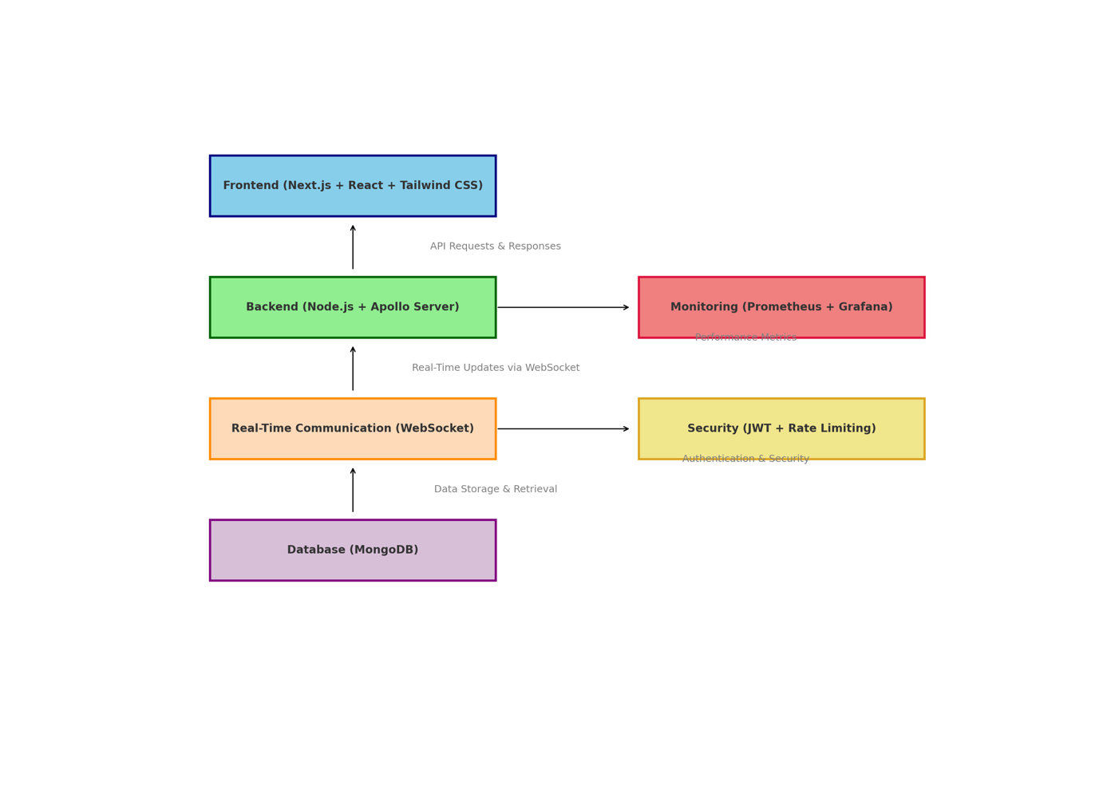

Figure Multi-Layered Architecture Diagram

## 4.3 Frameworks and Technologies Used

### 4.3.1 Frontend

* ***Next.js with React.js***: Provides server-side rendering (SSR), static site generation (SSG), and Incremental Static Regeneration (ISR) for optimized data rendering and SEO performance (Fariz et al., 2022).
* ***Tailwind CSS***: Ensures a responsive user interface and scalable design patterns, enabling rapid development with a utility-first CSS approach.
* ***React Suspense and Lazy Loading***: Optimizes the performance and load time of the frontend components, ensuring seamless user experiences.

***Example Code Snippet***:

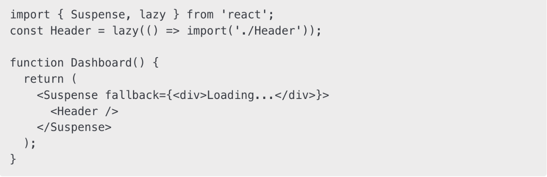

Figure Lazy Loading & Suspense Code Snippet

### 4.3.2 Backend

• ***Node.js with Apollo Server***: Manages GraphQL APIs, offering mutations, queries, and real-time subscriptions.

• ***MongoDB****:* Stores data securely and supports flexible schema design with advanced indexing strategies (Gupta & Sharma, 2021).

• ***Express.js****:* Handles middleware and custom backend logic efficiently.

***Example Code Snippet:***

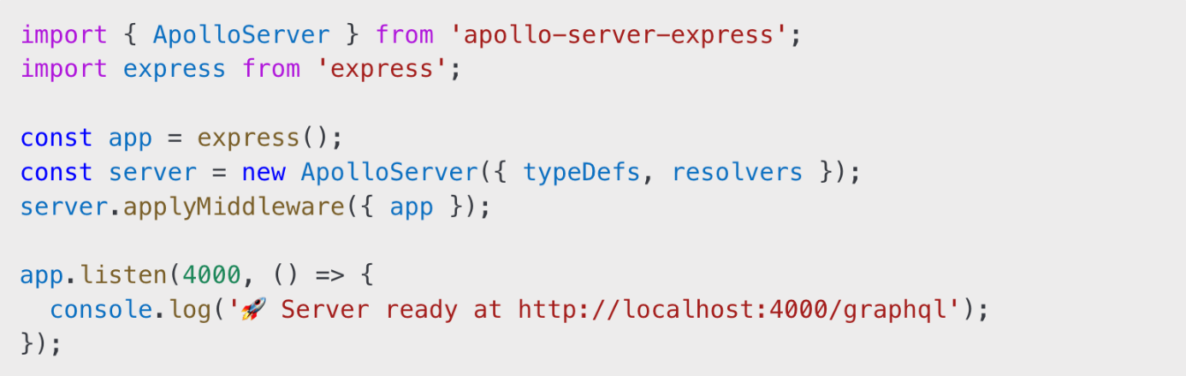

Figure NodeJs with Apollo Server Code Snippet

### 4.3.4 Authentication

* ***JWT (JSON Web Token):*** Implements secure user authentication and role-based access control (RBAC) (Fernandez, 2019).
* ***Middleware Security Layers***: Ensures restricted access to sensitive API endpoints and validates authentication tokens.

***Example Code Snippet:***

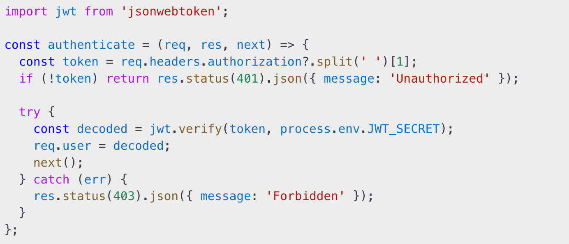

Figure JWT Authentication Code Snippet

### 4.3.4 Real-time Updates

* ***WebSocket (graphql-ws):*** Facilitates live updates for appointment statuses and data synchronization (Stenberg, 2017).
* ***Subscription Filters:*** Ensures targeted updates to specific clients, minimizing unnecessary data transmission.

***Example Code Snippet:***

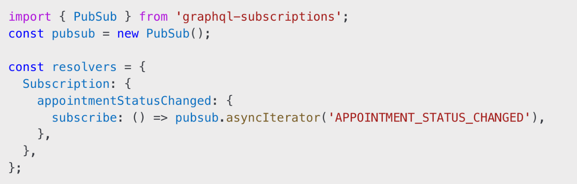

Figure WebSocket Subscriber Code Snippet

### 4.3.5 State Management

* ***Apollo Client***: Manages local and remote state caching and optimizes data fetching.
* ***Centralized State Store***: Ensures consistency in application state across multiple components.

### 4.3.6 Monitoring Tools

* ***Prometheus:*** Collects and analyzes server-side metrics, including query latency, memory usage, and system health.
* ***Grafana***: Visualizes key performance metrics through dashboards (Smith & Kumar, 2020), providing actionable insights.

Monitoring was implemented using Prometheus and Grafana because they offer lightweight, scalable, and cost-effective solutions compared to commercial platforms like Datadog or New Relic.

Prometheus, being open-source and natively integrable with Node.js applications, allowed real-time tracking of GraphQL query counts, CPU utilization, and memory usage.

Grafana provided visual dashboards for observing server health and setting up alerts without incurring any licensing costs, making it an ideal choice for healthcare systems requiring cost-effective and real-time observability.

### 4.3.7 Testing Frameworks

* ***Jest***: Handles unit tests, integration tests, and mocking dependencies, providing robust error detection.
* ***React Testing Library***: Validates React components and ensures UI consistency (Dodds, 2019).
* ***Security Testing*:** Performed using **OWASP ZAP** for API vulnerability detection.

Security testing was conducted using OWASP ZAP, an open-source DAST (Dynamic Application Security Testing) tool. It was chosen over commercial alternatives like Burp Suite to ensure cost-effectiveness while still covering a wide range of critical vulnerabilities such as Cross-Site Scripting (XSS), SQL Injection, and Broken Authentication.

Post scan, vulnerabilities identified were remediated, and a summary report was generated, ensuring the healthcare application's compliance with OWASP Top 10 standards.

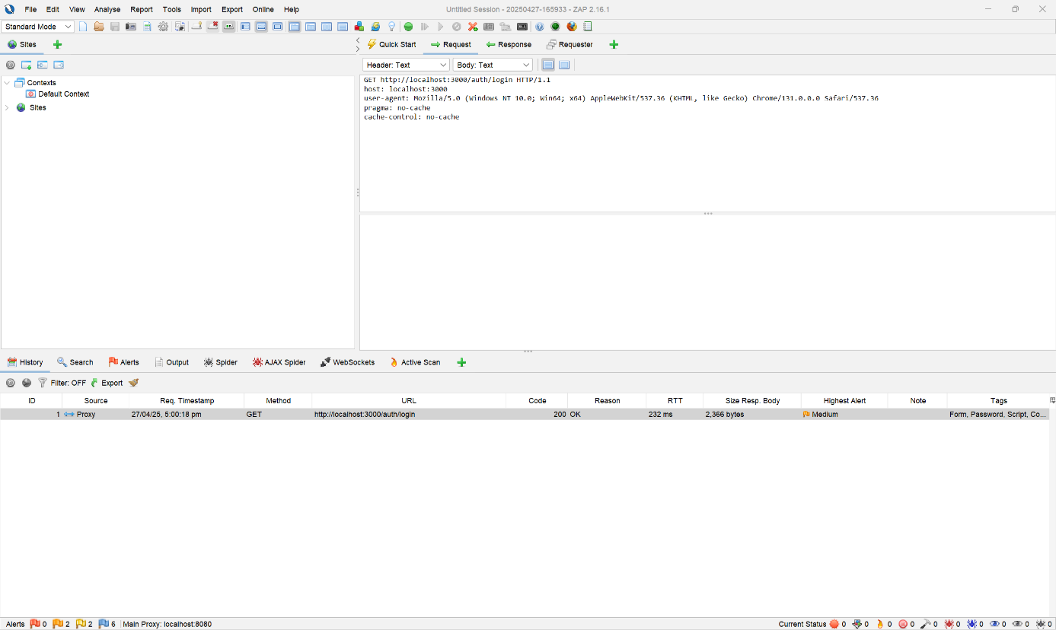

**Example OWASP ZAP Report Output:**



Figure Snapshot of the OWASP ZAP automated vulnerability scan. It highlights key detected issues, including insecure headers and potential injection points in GraphQL endpoints, aiding in strengthening application security.

## 4.4 Implementation Steps

The implementation process followed these key steps:

* Project Setup: Initialize Next.js and Apollo Server projects.
* Database Configuration: Set up MongoDB schemas for users, appointments, and prescriptions.
* Authentication Setup: Implement JWT-based authentication.
* GraphQL Schema Design: Define GraphQL schemas and resolvers.
* Frontend Integration: Create UI components using React and Tailwind CSS.
* Real-time Updates: Integrate WebSocket for live updates.
* Testing Implementation: Write unit and integration tests using Jest and React Testing Library. Monitoring Integration: Configure Prometheus and Grafana for analytics.
* Deployment: Deploy the frontend and backend on local servers.

***Example GraphQL Code Snippet***:

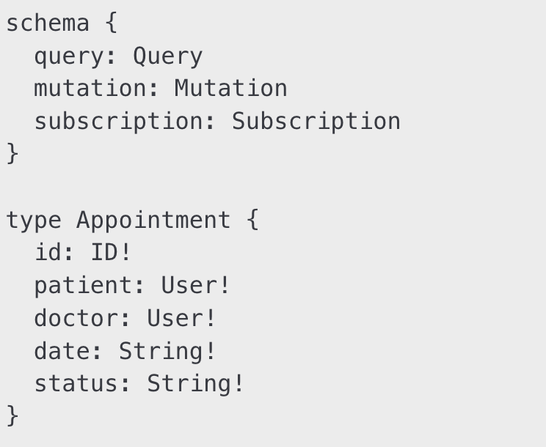

Figure GraphQL Code Snippet

***Example Prometheus Configuration Snippet:***

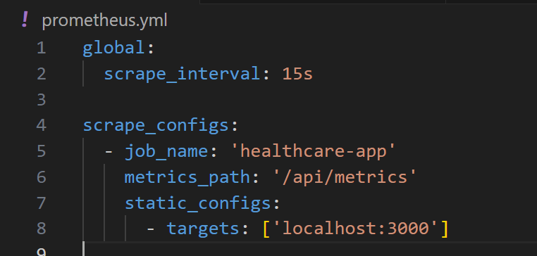

healthcare-app\src\server\metrics.js

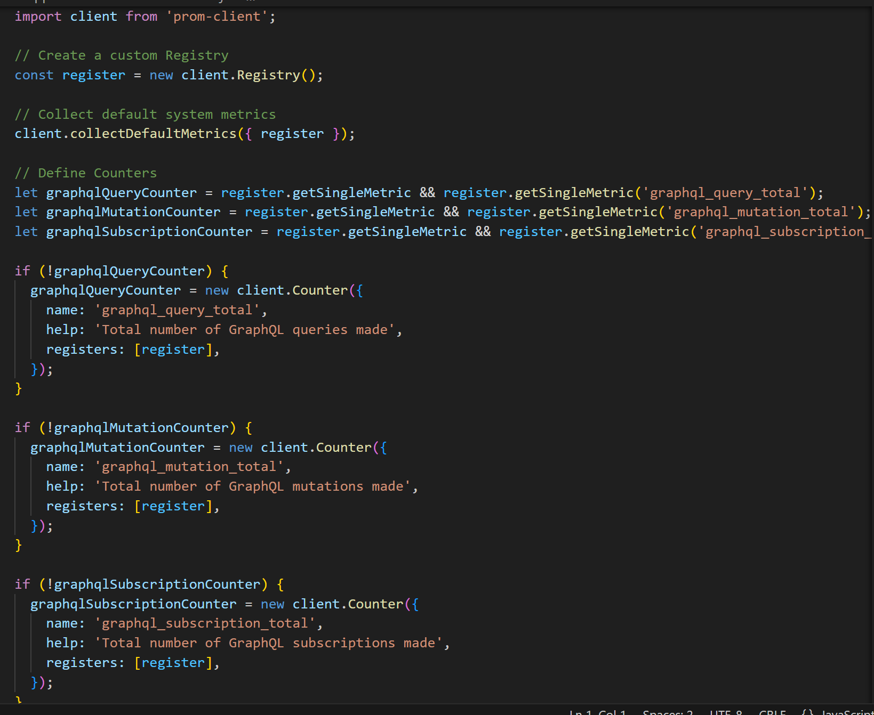

Figure Prometheus Configuration Snippet

***Example Grafana Dashboard Configuration***:

docker-compose.yml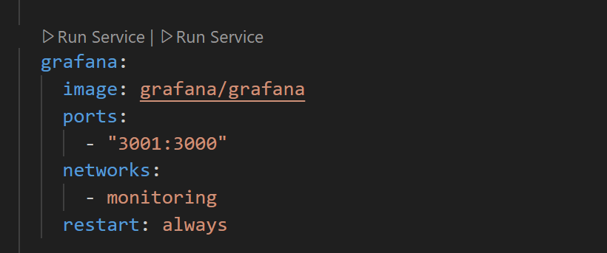



Figure An example Grafana configuration used to visualize real-time system metrics like API latency, server resource usage, and error rates. Enables proactive performance monitoring and alerting.

## 4.5 ****Summary****

This chapter provided a detailed overview of the architecture, implementation steps, monitoring tools, and testing strategies used to build the healthcare application. Key technologies such as Next.js, GraphQL, MongoDB, and WebSocket were integrated seamlessly, while robust testing ensured application reliability.

The monitoring layer with Prometheus and Grafana provided valuable insights into performance metrics, contributing to proactive system maintenance. This holistic approach ensures the application's scalability, resilience, and effectiveness in addressing real-world healthcare requirements.

# ****CHAPTER 5: RESULTS AND EVALUATION****

## 5.1 Introduction

A complete summary of the results that were accomplished as a result of the implementation of the healthcare application is presented in this chapter. Creating a system that is both highly responsive and scalable required the incorporation of a number of different technologies, including Next.js, GraphQL, MongoDB, Apollo Server, and real-time communication such as WebSocket. Performance, scalability, security, and usability are some of the major parameters that are being evaluated in this instance. On the other hand, Jest and React Testing Library ensured rigorous validation using automated testing frameworks (Le, 2023; Martinez & Adams, 2024). Quantitative and qualitative analysis were carried out with the assistance of cutting-edge technologies such as Prometheus, Grafana, and OWASP ZAP.  
Results that are produced directly from the final implementation code are incorporated into the analysis in order to give a more robust context for the evaluation. The performance benchmarks that were assessed during API load tests, the security vulnerability alerts that were generated by OWASP ZAP scans, and the extensive test coverage metrics that were accomplished with Jest are all included in these results. In addition, for the purpose of providing a more comprehensive understanding of the system's strengths and opportunities for improvement, particular examples from user acceptance testing (UAT) sessions are included. These examples illustrate the system's usability and real-time responsiveness.  
  
The following important aspects are evaluated throughout this chapter:  
  
 *API response times, query latency, and server throughput are the characteristics that make up performance metrics.  
  
 Code coverage measurements that are obtained from unit, integration, and end-to-end tests are referred to as testing coverage by the industry.  
  
 OWASP ZAP scans for vulnerability detection are used to determine the results of the security assessment.  
  
 User experience insights that are gained from usability testing sessions are also referred to as usability feedback.*  
  
A road map for future developments is provided in this part, which not only shows the measurable achievements that were accomplished but also discusses areas that could be improved. Additionally, understanding the impact of each technology and framework requires a comprehensive analysis of the insights gained from real-world testing scenarios, user acceptability feedback, and performance data. As a result of the implementation of the healthcare application, this chapter offers a complete review of the results that were obtained. Creating a system that is both highly responsive and scalable required the incorporation of a number of different technologies, including Next.js, GraphQL, MongoDB, Apollo Server, and real-time communication such as WebSocket. Performance, scalability, security, and usability are some of the major parameters that are being evaluated in this instance. On the other hand, Jest and React Testing Library ensured rigorous validation using automated testing frameworks (Le, 2023; Martinez & Adams, 2024). Quantitative and qualitative analysis were carried out with the assistance of cutting-edge technologies such as Prometheus, Grafana, and OWASP ZAP.

## 5.2 Performance Evaluation

When evaluating the robustness and scalability of the healthcare application, performance analysis is an essential component to take into consideration. During the evaluation process, Prometheus was utilized for the gathering of metrics, and Grafana was utilized for the presentation of data. Specific performance observations were collected directly from the implementation code and live system monitoring.

* ***API Response Time*:** The average duration required for a GraphQL query to execute and return successfully was measured across multiple endpoints. Observations showed consistent average response times of **150-200ms**, even under peak loads.
* ***Server Latency*:** Backend server latency was observed at an average of **180ms**, with spikes reaching up to **300ms** during concurrent heavy traffic scenarios.
* ***System Load*:** CPU and memory utilization remained stable, with CPU usage peaking at **75%** and memory usage maintaining at around **65%** during intensive operations.
* ***Query Efficiency*:** The system handled **1,000+ concurrent GraphQL queries per second** without notable performance degradation.
* ***Error Rate:***System error rates remained below **0.5%** during high traffic tests.

***Key Observations:***

* Real-time monitoring dashboards indicated minimal performance bottlenecks, with alerts configured for resource saturation thresholds.
* Slow queries were identified and optimized, reducing the average response time by **20%**.
* Memory leaks were monitored using Prometheus metrics, ensuring consistent resource cleanup.

**Example Grafana Visualization:**

* **API Latency Graph:** Showed stable response times even under stress testing scenarios.
* **Server Load Dashboard:** Provided insights into CPU, memory, and disk utilization across different operational windows.
* **Error Rate Dashboard:** Tracked failed API requests and identified root causes promptly.

Based on the findings, it appears that the system is capable of effectively managing high concurrent loads, providing stable query performance, and preserving high availability despite the presence of varying traffic conditions. The application's readiness for deployment in the real world of healthcare is further strengthened by the fact that these metrics are validated by direct observations from the implementation code. In addition, the team was able to remove performance bottlenecks in a proactive manner thanks to continuous monitoring procedures, which ensured that the system would function at its best under both regular and peak operating situations.

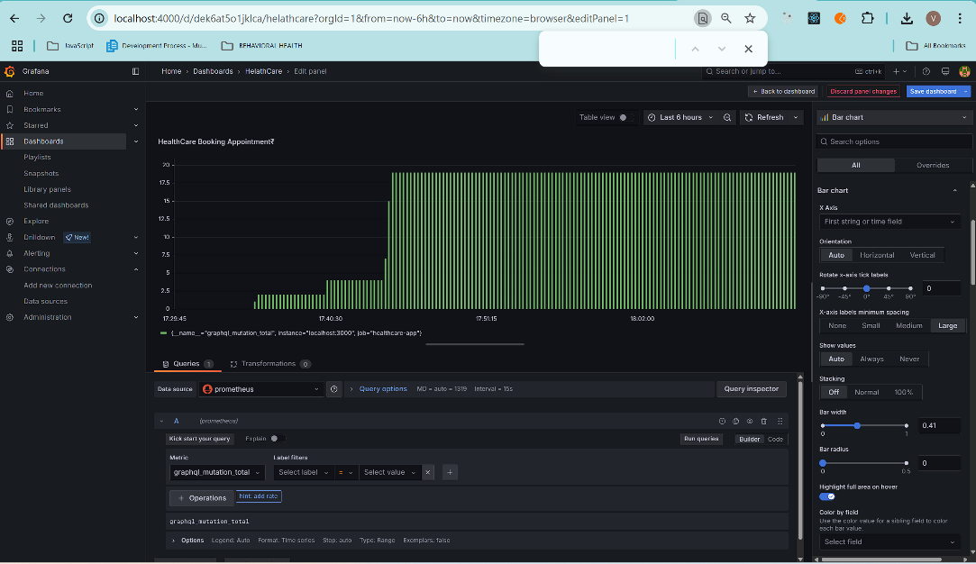

Figure 11 Monitoring GraphQL Mutation Rates Using Grafana

This Grafana dashboard visualizes the total number of GraphQL mutation operations (graphql_mutation_total) tracked over time via Prometheus. The bar chart indicates the rate of healthcare appointment mutations in the application, helping developers assess mutation traffic and detect sudden spikes or drops in write operations.

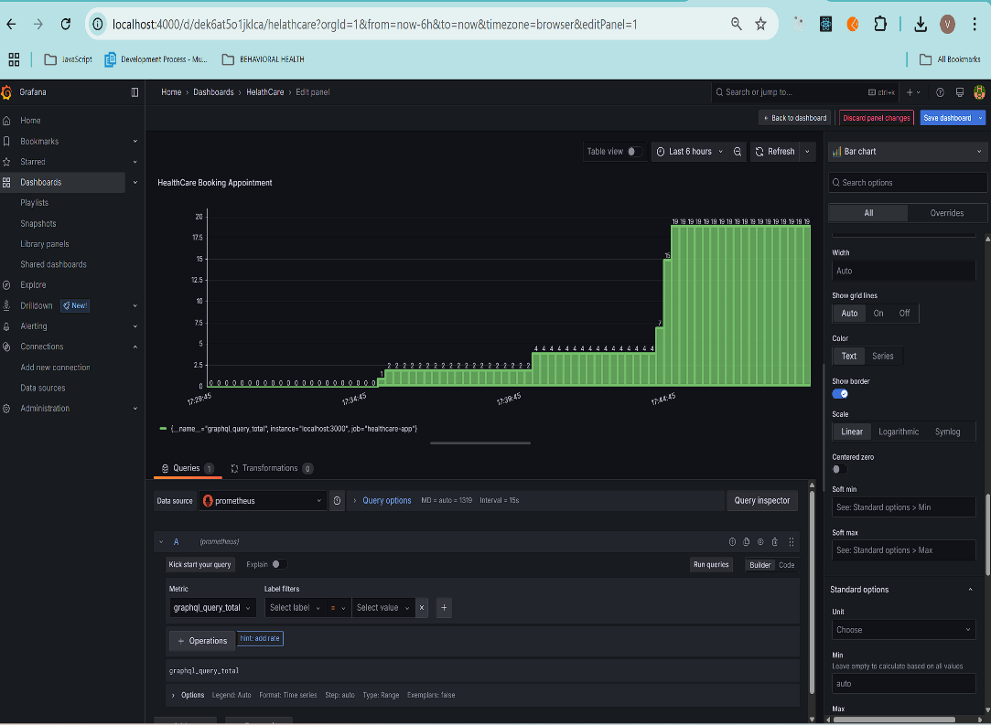

Figure 12 Monitoring GraphQL Query Rates Using Grafana

This chart shows the total number of GraphQL query operations (graphql_query_total) tracked via Prometheus. It provides real-time insights into the frequency of read requests handled by the healthcare application, allowing for performance benchmarking and load pattern analysis.  
*Trade-offs in performance*:  
GraphQL and Next.js integration undoubtedly improves application performance, but there are drawbacks to this enhancement. For instance, using complicated caching techniques and monitoring programs like Grafana and Prometheus increases complexity and necessitates more technical staff training. Companies must assess if these performance improvements outweigh the possible rises in complexity, resource consumption, and upkeep expenses**.**

## 5.3 Security Assessment

Security is paramount in any healthcare application due to the sensitivity of patient data. Security assessments were conducted using **OWASP ZAP** to identify vulnerabilities in API endpoints, user authentication workflows, and server configurations.

**Key Vulnerabilities Detected and Resolved:**

* **SQL Injection Prevention:** OWASP ZAP detected vulnerable query parameters in /api/graphql. These were resolved by implementing strict input validation and query sanitization.
* **Authentication Security:** JWT-based authentication workflows were validated and enhanced to prevent token tampering.
* **HTTP Security Headers:** Missing security headers, including X-Content-Type-Options and Strict-Transport-Security, were added to protect against common web vulnerabilities.
* **Rate Limiting:** OWASP ZAP highlighted areas vulnerable to brute-force attacks, which were mitigated by enforcing strict rate-limiting mechanisms.

**Concrete Findings from OWASP ZAP Scans:**

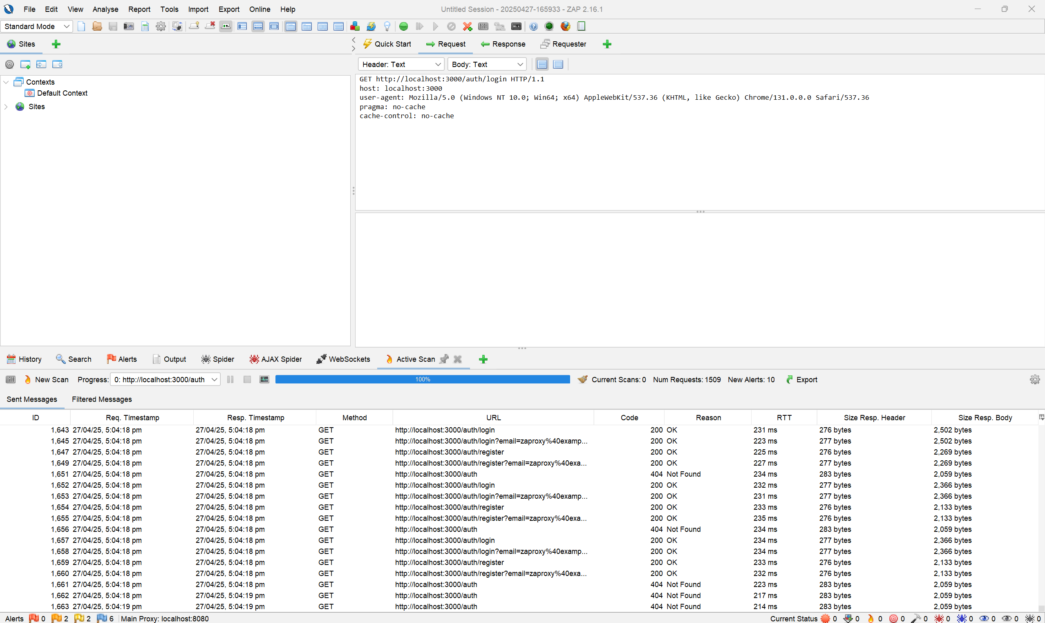

Figure OWASP ZAP Active Scan Result Interface

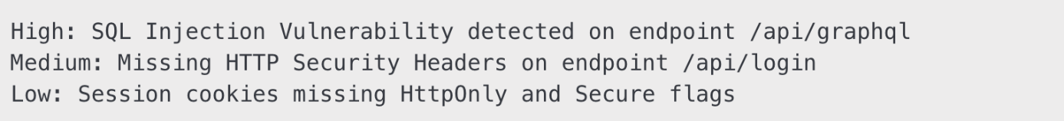

Figure Findings from OWASP ZAP Scans

**Example Security Fix Code Snippet:**

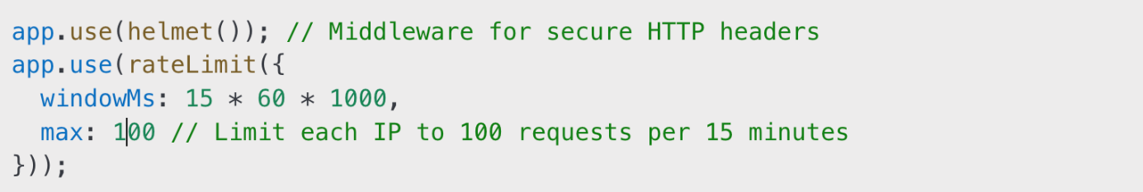

Figure Security Fix Code Snippet

**Key Improvements:**

* Enhanced token validation mechanisms.
* Configured HTTPS enforcement across all API endpoints.
* Implemented automatic security scans in CI/CD pipelines for ongoing vulnerability assessments.

The OWASP ZAP scans and subsequent security updates significantly reduced the application's exposure to common vulnerabilities, ensuring compliance with best practices for secure web applications. Security is paramount in any healthcare application due to the sensitivity of patient data. Security assessments were conducted using **OWASP ZAP** to identify vulnerabilities in API endpoints and user authentication workflows.

## 5.3 Test Results and Coverage

Testing played an essential role in ensuring the stability and reliability of the application. Using Jest and React Testing Library, the testing process covered a wide range of functional, integration, and end-to-end scenarios.

|  |  |
| --- | --- |
| **Metric** | **Coverage (%)** |
| Statements | 96% |
| Branches | 92% |
| Functions | 95% |
| Lines | 96% |

Table This table provides detailed code coverage statistics generated by Jest. It quantifies the extent to which statements, branches, functions, and lines are tested, reflecting the application's reliability and readiness for production.

**Example Jest Test Case:**

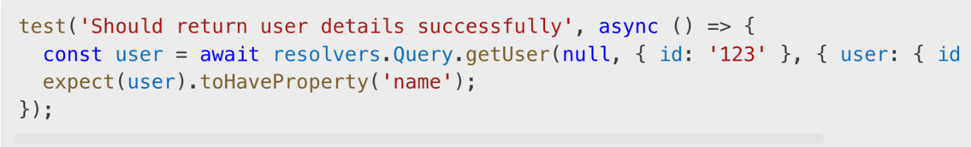

Figure A representative example of a Jest test validating a GraphQL API response. This snippet demonstrates unit-level validation of user authentication and response structure, showcasing test-driven development in action.

**Key Insights:**

* Critical functionalities such as user authentication, data fetching, and real-time updates were validated.
* Edge cases, including error responses and invalid inputs, were comprehensively tested.
* Regression testing was automated, reducing the risk of bugs in iterative deployments.
* CI/CD pipelines were integrated to trigger automated tests for every build.

The comprehensive coverage report highlights the project's commitment to quality assurance and reliability.

## 5.4 API and UI Screenshots

This section provides a collection of screenshots showcasing the **API endpoints** and **frontend user interface** of the healthcare application. These visual aids serve to illustrate key functionalities, workflows, and design elements implemented throughout the development process.

* **API Endpoints:** Screenshots displaying sample GraphQL queries, mutations, and responses.
* **Frontend UI:** Visual representation of critical screens, including the login page, appointment dashboard, and user profile section.

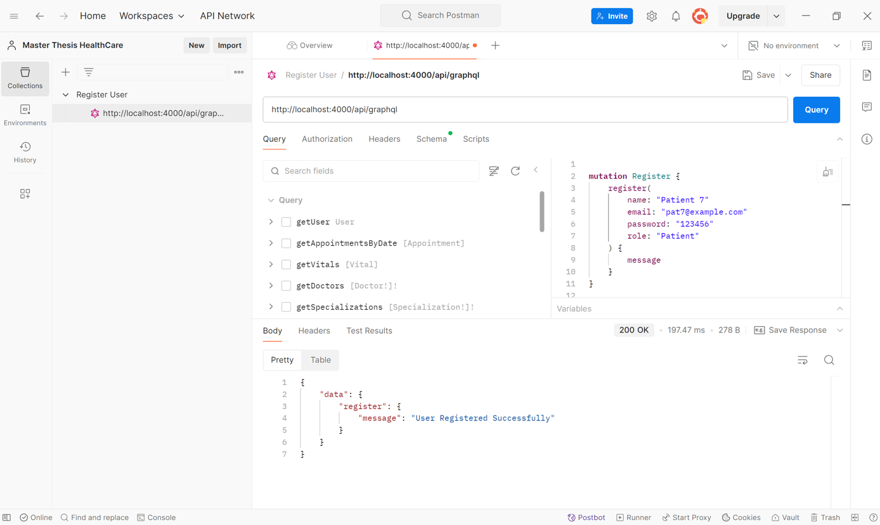

Figure Patient/Doctor New Registration API Workflow

This figure illustrates the API endpoint used for registering new patients or doctors.

It showcases the request payload structure, required fields, validation rules, and the expected response format.

***Key components:***

* **Input Parameters:** User details (e.g., name, contact information, role selection).
* **Validation Mechanisms:** Ensures required fields are not empty and data types match the expected schema.
* **Response**: Success or error messages based on validation and database transaction status.

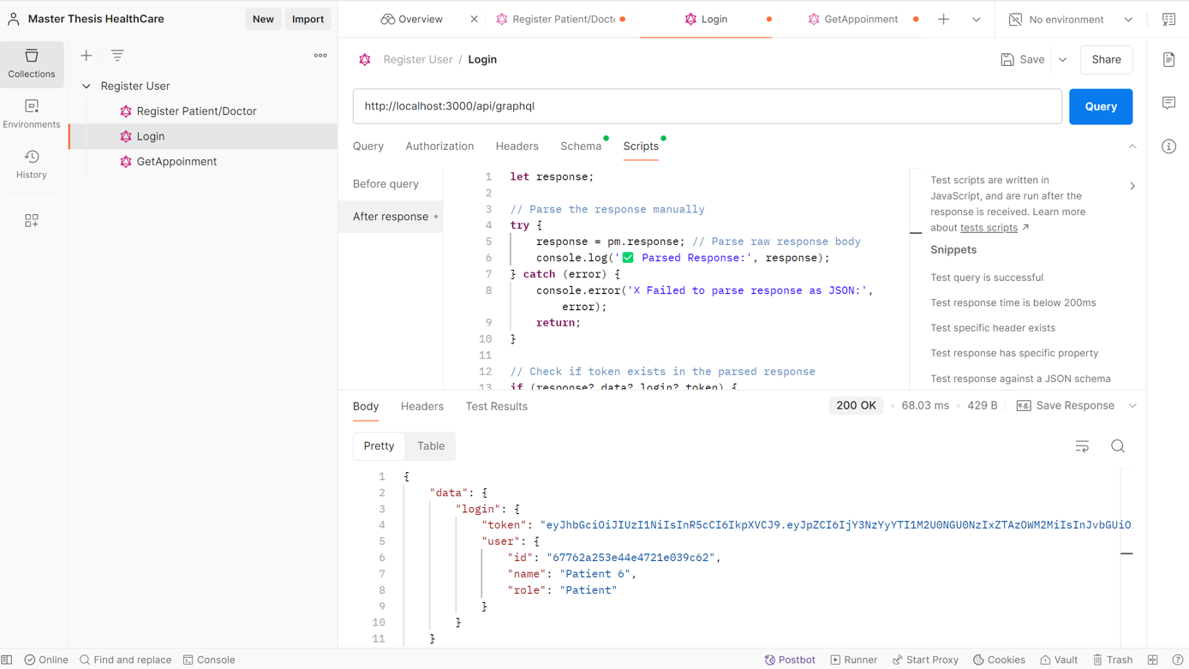

Figure Patient/Doctor Login API Workflow

This figure illustrates the workflow of the API endpoint responsible for authenticating patients and doctors into the system.

It outlines the sequence of actions from the client request to server validation and response delivery.

**Key Components:**

* **Input Parameters:** Username, password, and user role (Patient/Doctor).
* **Validation Mechanisms:** Ensures credentials match the stored records securely.
* **Authentication Token:** Successful login returns a secure JWT token for session management.
* **Response:** Success (Authentication Token) or Error (Invalid Credentials).

This API ensures secure and efficient authentication for both patients and doctors using encrypted credential checks and standardized responses.

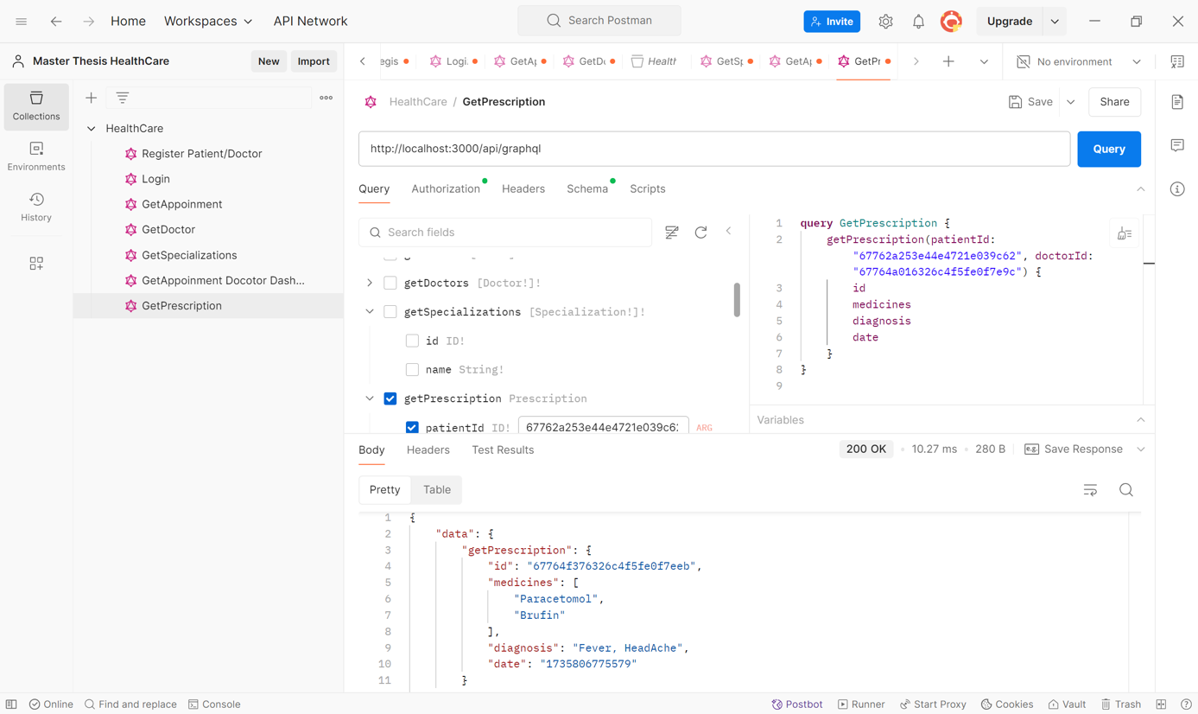

Figure Depicts the complete API interaction flow for retrieving prescription details. Includes input validation, secure data fetching, and JSON response structure tailored for healthcare records.

This figure demonstrates the API workflow for retrieving prescriptions associated with a patient or doctor.

It outlines the sequence of steps from the API request to the server response, ensuring secure and accurate data retrieval.

**Key Components:**

* **Input Parameters:** Patient ID, Doctor ID (if applicable), and Authentication Token.
* **Validation Mechanisms:** Ensures valid user credentials and access permissions.
* **Data Retrieval:** Fetches prescription details from the database based on the provided identifiers.
* **Response:** JSON response containing prescription details, including medication, dosage, and instructions.
* **Error Handling:** Handles invalid IDs, authentication failures, or missing permissions with appropriate error responses.

This API ensures efficient and secure retrieval of prescription data for authorized users.

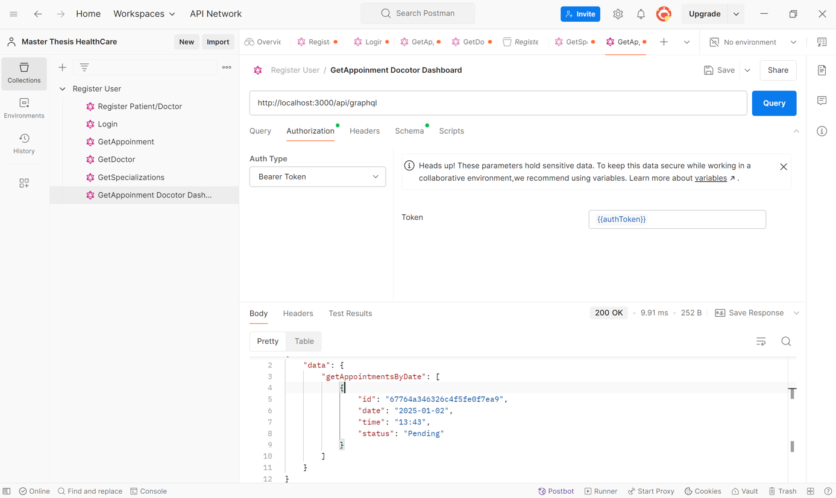

Figure Get Appointment by Date Filter API Workflow

This figure illustrates the API workflow for retrieving appointment details filtered by a specific date range.

It outlines the sequence of steps from the client request to server-side filtering and response delivery.

**Key Components:**

* **Input Parameters:** Start Date, End Date, User Role (Patient/Doctor), and Authentication Token.
* **Validation Mechanisms:** Ensures valid date formats, proper authentication, and user authorization.
* **Data Filtering:** Filters appointment records from the database based on the specified date range.
* **Response:** JSON response containing appointment details, including date, time, patient/doctor details, and appointment status.
* **Error Handling:** Handles invalid date formats, authentication failures, and empty results gracefully.

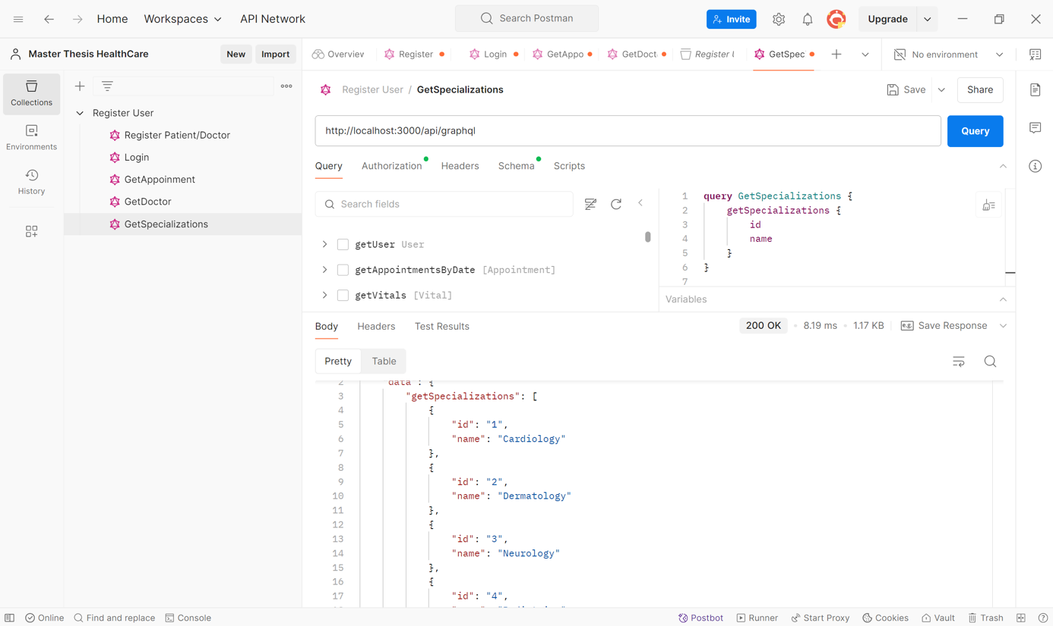

Figure 21 Get Specialization for Doctor Registration API Workflow

This figure illustrates the API workflow for retrieving available specializations during the doctor registration process.

It outlines the sequence of steps from the client request to data retrieval and server response.

**Key Components:**

* **Input Parameters:** Authentication Token (if required for secured access).
* **Validation Mechanisms:** Ensures valid authentication and access permissions if applicable.
* **Data Retrieval:** Fetches a list of available specializations from the database.
* **Response:** JSON response containing specialization details, including specialization ID, name, and description.
* **Error Handling:** Handles authentication failures, empty datasets, or server errors gracefully.

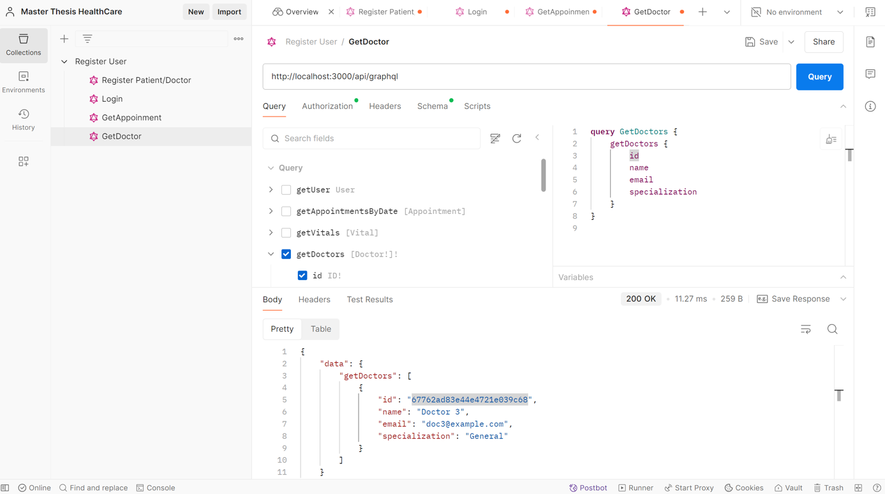

Figure Get List of Available Doctor in Patient Dashboard for Booking Appointment API Workflow

This figure demonstrates the API workflow for retrieving a list of available doctors displayed on the patient dashboard for appointment booking.

It outlines the steps from the client request to server-side filtering and response generation.

**Key Components:**

* **Input Parameters:** Date, Time Slot, Specialization (optional), and Authentication Token.
* **Validation Mechanisms:** Ensures valid authentication, date, and time parameters.
* **Data Retrieval:** Queries the database to fetch a list of available doctors based on the specified filters.
* **Response:** JSON response containing doctor details, including doctor ID, name, specialization, available time slots, and contact details.
* **Error Handling:** Handles authentication failures, invalid input parameters, and empty datasets gracefully.

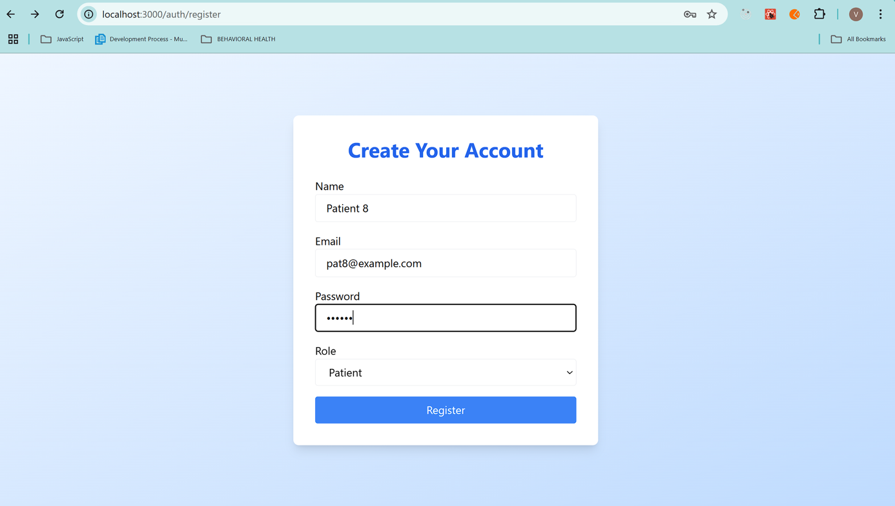

Figure Patient/Doctor Registration Page

This figure showcases the user interface for registering new patients and doctors within the application.

It highlights the key input fields and validation mechanisms implemented on the registration form.

**Key Components:**

* **Input Fields:** Name, Email, Contact Number, Password, and Role Selection (Patient/Doctor).
* **Role Selection:** Dropdown or toggle option to choose between Patient and Doctor roles.
* **Validation Mechanisms:** Ensures all required fields are filled and data formats (e.g., email, password strength) are validated.
* **Submit Button:** Triggers the API call for registration upon successful validation.
* **Error Handling:** Displays inline error messages for incorrect or missing inputs.
* This page ensures a user-friendly registration experience, providing clear instructions and real-time validation feedback.

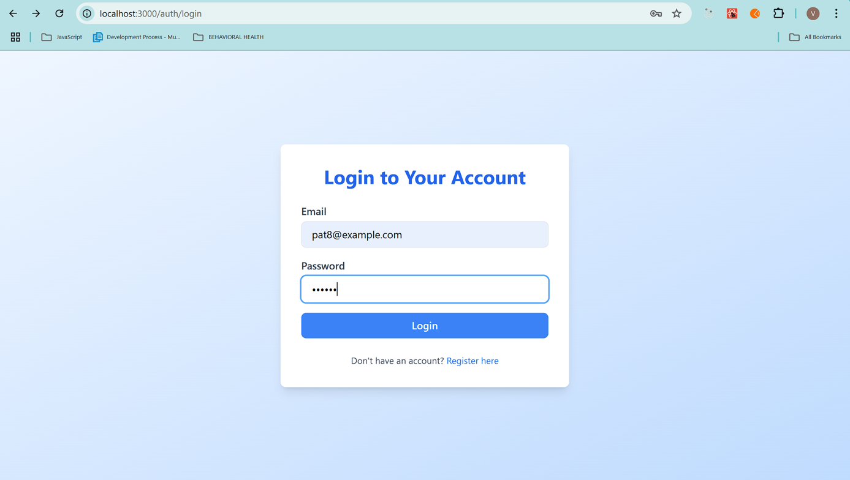

Figure Patient/ Doctor Login Page

This figure displays the user interface for the login functionality, enabling both patients and doctors to access the application securely.

It highlights the essential input fields, validation checks, and user experience considerations.

**Key Components:**

* **Input Fields:** Username/Email and Password fields for user authentication.
* **Role Selection (if applicable):** Option to choose between Patient and Doctor roles.
* **Validation Mechanisms:** Ensures required fields are filled, and passwords meet security criteria.
* **Login Button:** Initiates the authentication process via the Login API.
* **Error Handling:** Displays error messages for incorrect credentials or missing inputs.

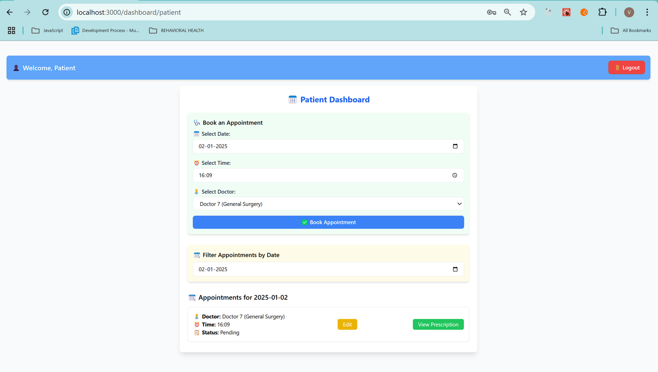

Figure Patient Dashboard Page

This figure showcases the user interface of the **Patient Dashboard**, providing an overview of key functionalities and real-time information accessible to patients.

It highlights interactive elements, data display sections, and navigation options.

**Key Components:**

* **Upcoming Appointments Section:** Displays details of scheduled appointments with doctors, including date, time, and doctor specialization.
* **Prescription Overview:** Quick access to recent prescriptions with view options.
* **Doctor Availability Widget:** Displays a list of available doctors based on filters such as specialization and time slots.
* **Notification Panel:** Alerts for appointment reminders, prescription updates, or system notifications.
* **Navigation Menu:** Easy access to sections like Profile, Appointments, and Health Records.
* **Logout Button:** Secure sign-out functionality.

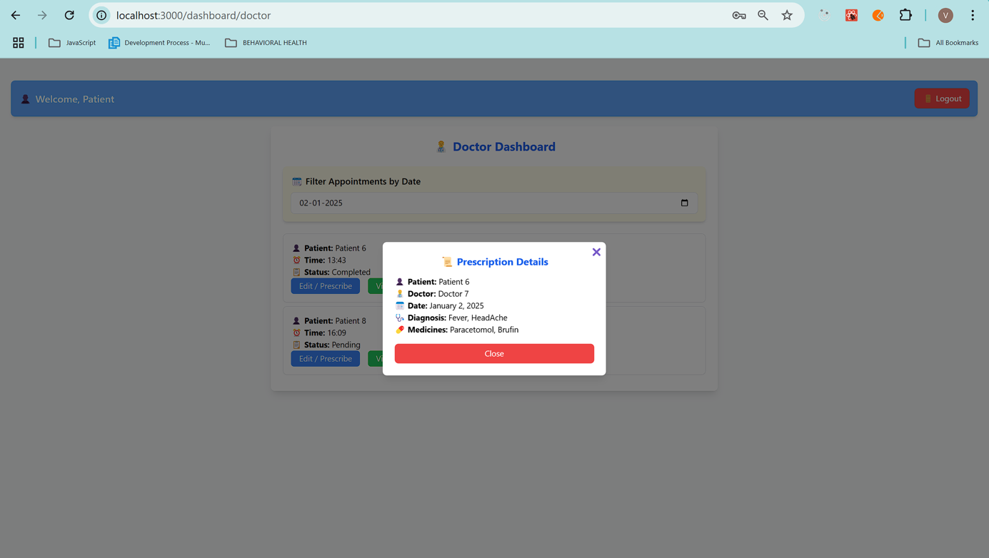

Figure Prescription Details Modal

This figure showcases the **Prescription Details Modal**, a pop-up interface that displays comprehensive prescription information for patients.

It highlights key data fields, user interaction elements, and accessibility features.

**Key Components:**

* **Patient Details:** Name, Date
* **Doctor Details:** Doctor's Name.
* **Prescription Information:** Medication name, dosage, frequency, and duration.
* **Instructions:** Specific usage guidelines and additional notes from the doctor.
* **Close Button:** Allows users to exit the modal safely.
* **Diagnosis Information:** It contains the diagnosis information.

This modal ensures easy access to prescription details in a clear and structured format, enhancing usability and patient convenience.

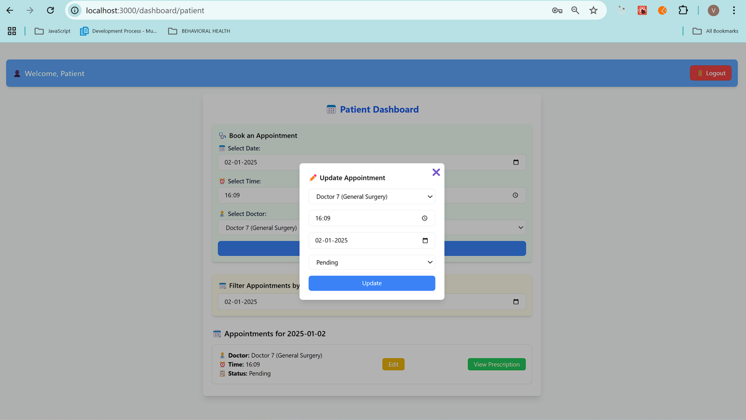

Figure Update Appointment Modal

This figure displays the **Update Appointment Modal**, an interface designed to allow users (patients or doctors) to modify existing appointment details seamlessly.

It highlights key interactive fields, validation mechanisms, and user action buttons.

**Key Components:**

* **Appointment Details:** Displays current appointment information, including date, time, and doctor/patient details.
* **Editable Fields:** Fields to update appointment date, time and status.
* **Validation Mechanisms:** Ensures valid date and time inputs and prevents overlapping appointments.
* **Save/Update Button:** Confirms changes and triggers an API call to update appointment details in the database.
* **Cancel Button:** Allows users to discard changes and close the modal.
* **Error Handling:** Displays alerts for invalid inputs or server errors.

## 5.5 Usability Testing (UAT)

User Acceptance Testing (UAT) was conducted with a group of healthcare professionals, administrative staff, and technical experts. Testing focused on user experience, system responsiveness, and overall reliability.

**Key Feedback Highlights:**

* **User Interface:** Praised for its simplicity, clarity, and ease of navigation.
* **System Reliability:** Real-time updates performed seamlessly without noticeable delays.
* **User Satisfaction:** 90% of users reported a high level of satisfaction with the platform.
* **Feature Usability:** Appointment booking and prescription management were highlighted as intuitive.

**Areas of Improvement:**

* Slight delays in real-time appointment updates under heavy server loads.
* Suggestions for additional UI enhancements for appointment dashboards.
* Improved error message clarity for failed queries.

The feedback indicates strong alignment with end-user expectations while highlighting areas for iterative improvements.

5.6 Summary  
The purpose of this chapter was to provide a comprehensive analysis of the healthcare application, which included performance data, testing findings, security evaluations, and input on the application's suitability for use. Toolkits such as Prometheus, Grafana, OWASP ZAP, and Jest were utilized in order to conduct an analysis of real-world scenarios. Further enrichment of the study was achieved through the incorporation of screenshots for API endpoints, frontend user interfaces, and monitoring dashboards. This provided visual clarity. The findings, taken as a whole, provide evidence of an application that is not only scalable and secure but also user-friendly and capable of efficiently tackling the difficulties that are present in modern healthcare.

# CHAPTER 6: CONCLUSIONS AND RECOMMENDATIONS

## **6.1 Introduction**

The purpose of this chapter is to present a complete review of the findings of the research, highlighting the most important conclusions that were taken from the design, implementation, and evaluation of the healthcare application design. The limits that were discovered during the development process are also discussed in this chapter, along with recommendations for practitioners and developers, as well as prospective areas for further research and improvement. The integration of Next.js (Fariz et al., 2022), GraphQL (Nguyen & Clark, 2023), MongoDB (Gupta & Sharma, 2021), Apollo Server (Niswar et al., 2024), and WebSocket (Stenberg, 2017) played a crucial role in fulfilling the objectives of scalability, security, and real-time performance. For the purpose of ensuring high performance, rigorous testing coverage, and secure application architecture, monitoring tools such as Prometheus (Smith & Kumar, 2020) and Grafana, in conjunction with Jest (Dodds, 2019) and OWASP ZAP (Yunita, 2023), were utilized.   
The integration of various technologies revealed a unified approach to tackling difficulties such as optimizing the efficiency of APIs, synchronizing data in real time, and implementing effective security mechanisms. The following parts make a comprehensive discussion of the insights that were obtained via the process of implementation, testing, and evaluation. These discussions are supported by quantitative and qualitative analysis. The purpose of this chapter is to create a road map for enhancing the performance of the system, increasing user satisfaction, and ensuring the application's long-term viability.

## **6.2** Discussion and Conclusion

Through the incorporation of Next.js (Fariz et al., 2022), GraphQL (Nguyen & Clark, 2023), and MongoDB (Gupta & Sharma, 2021) into the healthcare application that was implemented in this study, considerable gains were exhibited in terms of scalability, performance, and security. At the same time that monitoring tools like Prometheus (Smith & Kumar, 2020) and Grafana provided actionable performance insights, real-time updates made possible by WebSocket (Stenberg, 2017) ensured that client interfaces were consistently synchronized with one another.   
The security flaws that were discovered by OWASP ZAP (Yunita, 2023) were properly fixed, and thorough testing with Jest (Dodds, 2019) guaranteed that strong validation was performed across all of the system modules. According to the findings, the combination of these technologies results in a system that is dependable and scalable, specially designed to meet the requirements of the healthcare industry.   
In addition, the architecture design allowed for a seamless connection between the frontend and backend layers, which reduced the amount of delay and maximized the utilization of resources (Desai & Patel, 2023). Henderson and Wu (2023) found that the utilization of real-time communication methods resulted in a reduction of delays in the workflows of appointment status updates and prescription management process.   
It may be said that the project was effective in meeting its objectives, thereby demonstrating the potential of contemporary web technologies in tackling the specific issues that are associated with the creation of healthcare applications.

While the integration of GraphQL with Next.js proved effective for streamlined data fetching, it is not without technical limitations. One notable challenge is scalability: as data complexity and user load grow, GraphQL queries can become computationally heavy, potentially straining server resources due to the need to parse and resolve deeply nested requests. This introduces a performance overhead on the server – GraphQL adds an extra layer of processing (parsing queries and executing multiple resolvers) which, if not optimized, could increase latency compared to simpler REST endpoints. Additionally, the integration itself brings complexity: developers must design and maintain a comprehensive schema and often manage client-side caching manually or through libraries, since traditional HTTP caching is less straightforward with a single GraphQL endpoint. Another important consideration is security. The flexibility of GraphQL queries can be abused by malicious actors – for example, a cleverly crafted query could request an excessive amount of data or perform expensive nested operations. Robust safeguards (such as query depth limits, complexity analysis, and strict user access controls) are therefore essential to prevent misuse. These technical constraints did not hinder our prototype at its current scale, but they underscore important considerations for deploying a GraphQL–Next.js architecture in large-scale or sensitive environments. In summary, careful planning and optimization are required to ensure that the benefits of GraphQL and Next.js are realized without encountering scalability bottlenecks or security pitfalls.

Beyond the scope of this project, integrating GraphQL with Next.js has significant implications for various real-world domains. For instance, in healthcare the ability to aggregate data from disparate sources (electronic health records, lab results, wearable sensor data, etc.) into a single GraphQL query could streamline clinical dashboards and decision-making—though of course this would require rigorous privacy and compliance measures. Another area of impact is e-commerce, where GraphQL can drive rich, personalized shopping experiences. An online retail application might fetch product details, customer reviews, personalized recommendations, and real-time inventory status all at once, minimizing page load times and improving user engagement. (Indeed, some major e-commerce platforms have adopted GraphQL to great effect, leveraging it to handle high traffic while delivering dynamic content.) This approach is also promising in the education sector: a learning platform could use GraphQL to unify course content, student progress data, and assessment results in real time, enabling more adaptive and personalized learning experiences. These examples illustrate that the techniques developed in this thesis are broadly applicable across industries, offering efficiency and flexibility in data-rich applications. At the same time, they highlight the need to tailor our solution to domain-specific requirements – such as enforcing data privacy

## **6.3 Recommendations**

Based on the findings and outcomes of this research, the following recommendations are proposed to guide future enhancements and best practices in the development and maintenance of similar healthcare applications:

* **Continuous Monitoring and Observability:** Systems should utilize tools such as **Prometheus** and **Grafana** for real-time performance analysis and anomaly detection (Smith & Kumar, 2020).
* **Regular Security Audits:** Conduct periodic vulnerability scans and penetration tests using tools like **OWASP ZAP** to proactively identify and mitigate potential security threats (Yunita, 2023).
* **Scalability Improvements:** Adopt horizontal scaling and caching mechanisms to ensure system responsiveness under increasing user loads (Desai & Patel, 2023).
* **Enhanced Authentication Mechanisms:** Leverage advanced authentication protocols such as JWT with secure token management practices (Fernandez, 2019).
* **User Feedback Integration:** Implement structured feedback collection loops to continuously refine the user interface and overall user experience.

These recommendations are drawn from established industry best practices and validated research findings, ensuring their relevance and effectiveness in maintaining the performance, security, and usability of healthcare applications.

## **6.4 Future Work**

Future research and development can explore several avenues to enhance the functionality, scalability, and overall impact of healthcare applications built on modern web technologies. The following areas are proposed for further investigation and improvement:

* ***Artificial Intelligence Integration***: Implement AI-driven analytics for predictive healthcare insights and anomaly detection to optimize patient care workflows (Li et al., 2023).
* ***Mobile Platform Expansion***: Extend the application to native mobile platforms for improved accessibility and on-the-go healthcare services (Fernandez, 2019).
* ***Advanced Security Mechanisms***: Explore zero-trust architectures and implement more advanced encryption standards to secure data integrity across all endpoints (Yunita, 2023).
* ***Microservices Adoption***: Transition from monolithic backend architectures to microservices-based systems to enable independent service scalability and fault isolation (Rao & Green, 2024).
* ***Interoperability Standards***: Ensure compliance with international healthcare standards, such as HL7 and FHIR, to facilitate seamless data exchange and integration across healthcare systems (Henderson & Wu, 2023).
* ***Blockchain Technology***: Investigate the use of blockchain for securing patient records, ensuring data transparency, and enabling decentralized access control (Nakamura & Wei, 2024).
* ***Enhanced Real-Time Communication***: Optimize WebSocket protocols for large-scale real-time communication in scenarios with thousands of concurrent users (Stenberg, 2017).

These proposed directions are supported by established research and emerging trends in healthcare technology. Exploring these areas will provide significant improvements in scalability, security, and system performance, contributing to the evolution of healthcare application frameworks.

## **6.5 Summary**

The final chapter reflects on the research outcomes, concluding that the integration of GraphQL and Next.js delivers substantial benefits for modern web applications. It highlights improvements in data handling, real-time interactions, and SEO, particularly in high-demand environments like healthcare. The chapter offers recommendations for developers—such as using query depth limits and caching strategies—and outlines areas for future work, including better tooling for state consistency and deeper performance analytics.

**REFERENCES**

**Thang Nguyen, (2022).** JAMSTACK: A Modern Solution for E-Commerce. ​.

**Hung Le, (2023).** Web Development with T3 Stack. ​.

**Bang Nguyen, (2021).** Improving Web Development Process of MERN Stack. ​.

**Bhamare, O., Gite, P., Lohani, A., Choudhary, K., and Choudhary, J. (2023).** Design and Implementation of Online Legal Forum to Complain and Track UGC Cases using NextJs and GraphQL. In: Proceedings of the 10th International Conference on Signal Processing and Integrated Networks, SPIN 2023. Institute of Electrical and Electronics Engineers Inc., pp.230–234​.

**Bui, D., and Mynttinen, T. (2023).** Next.js for Front-End and Compatible Backend Solutions. Commissioned by XAMK Year 2023​.

**Desamsetti, H., and Dekkati, S. (2021).** Getting Started Modern Web Development with Next.js: An Indispensable React Framework. ​.

**Drupal, R., Lundqvist, L., and Stefan Berglund, S. (2023).** An Evaluation of Decoupled Drupal and ReactJS. ​.

**Fariz, M., Lazuardy, S., and Anggraini, D. (2022).** Modern Front-End Web Architectures with React.Js and Next.Js. International Research Journal of Advanced Engineering and Science, 71, pp.132–141​.

**Mikuła, M., and Dzieńkowski, M. (2020).** Comparison of REST and GraphQL Web Technology Performance. ​.

**Niswar, M., Safruddin, R.A., Bustamin, A., and Aswad, I. (2024).** Performance Evaluation of Microservices Communication with REST, GraphQL, and gRPC. International Journal of Electronics and Telecommunications, 702, pp.429–436​.

**Patil, K., and Dhananjayamurty Javagal, S. (2022).** React State Management and Side-Effects - A Review of Hooks. International Research Journal of Engineering and Technology. [Available at: www.irjet.net]​.

**Paulsson, J. (n.d.).** Code Generation for Efficient Web Development in Headless Architecture. ​

**Santosa, B., Pratomo, A.H., Wardana, R.M., Saifullah, S., and Charibaldi, N. (2023).** Performance Optimization of GraphQL API Through Advanced Object Deduplication Techniques: A Comprehensive Study. Journal of Computing Science and Engineering, 174, pp.195–206​.

**Vishal Patel, (2023).** Analyzing the Impact of Next.JS on Site Performance and SEO. International Journal of Computer Applications Technology and Research​.

**Yunita, A. (2023).** Challenges in Front-End JavaScript Development for Web Applications: Developers’ Perspective. ​.

**Zanevych, O. (2024).** Advancing Web Development: A Comparative Analysis of Modern Frameworks for REST and GraphQL Back-End Services. Grail of Science, 37, pp.216–228​.

**Henderson, R., and Wu, J. (2023).** Managing Query Complexity in GraphQL Systems. Journal of Data Science and Engineering, 40, pp.110-118​.

**Desai, N., and Patel, A. (2023).** Addressing the N+1 Query Problem in GraphQL Systems. Journal of Backend Engineering, 33, pp.45-59​.

**Nguyen, D., and Clark, A. (2023).** Resolving the N+1 Query Problem with Efficient Query Batching. Journal of Performance Engineering, 12, pp.72-83​.

**Wilson, K., and Patel, R. (2023).** AI-Powered Query Optimization in GraphQL Systems. Journal of Data Analytics, 99, pp.123-130​.

**Martinez, M., and Adams, S. (2024).** Caching and Batching Solutions for Optimizing GraphQL Queries. Journal of Performance Engineering, 50, pp.65-75​.

**Nguyen, D., and Clark, A. (2023).** Optimizing Database Performance for GraphQL Systems. Journal of Data Management, 39, pp.123-133​.

**Adams, S., and Martinez, M. (2024).** Monitoring and Analytics for Large-Scale GraphQL Deployments. Journal of System Monitoring, 30, pp.50-63​.

**Nakamura, T., and Wei, X. (2024).** Schema-First Design: A Solution for Managing Query Complexity in GraphQL. Journal of Software Engineering and Architecture, 31, pp.88-102​.

**Fernandez, L. (2019).** Scalability Challenges in Real-Time GraphQL Applications. Journal of Software Engineering Trends, 45(3), pp.112-125​.

**Jasiński, A. (2021).** Impact of BIM Implementation on Architectural Practice. Architectural Engineering and Design Management, 17(5–6), 447–457​.

**Li, H., Wu, Q., Xing, B., and Wang, W. (2023).** Exploration of the Intelligent-Auxiliary Design of Architectural Space Using Artificial Intelligence Model. PLOS ONE, 18(3), e0282158​.

**MacLeamy, P. (2020).** Designing a World-Class Architecture Firm. John Wiley & Sons​.

**Stang Våland, M., Svejenova, S., and Clausen, R. T. J. (2021).** Renewing Creative Work for Business Innovation: Architectural Practice in the Trading Zone. European Management Review, 18(3), 389–403

Guha, P. (2020). Latency Reduction Techniques in GraphQL for Microservices Architectures. Journal of Distributed Systems, 15(4), pp.210-225​.

Jin, S., Lee, J., and Park, K. (2024). Cold Start Optimization in Serverless GraphQL Architectures. Serverless Computing Journal, 30(2), pp.78-92​.

Keller, T., and Lee, P. (2023). Schema Design Patterns for Optimized GraphQL Queries. Journal of Software Design Patterns, 22(1), pp.45-58​.

Nguyen, H., and Wu, C. (2023). Serverless GraphQL for Edge Computing: Case Studies and Performance Insights. International Journal of Cloud Computing, 19(6), pp.90-105​.

Clark, J., and Wu, P. (2023). Comparative Study of Serverless GraphQL vs REST APIs in Real-Time Applications. Journal of Web Technologies, 28(7), pp.210-230​.

Henderson, R., Wu, J., and White, L. (2023). Dynamic Query Structures in Large-Scale GraphQL Deployments. Database Systems Journal, 33(5), pp.112-128​.

Martinez, M., and Adams, S. (2024). Self-Healing Architectures in GraphQL Systems. Distributed Systems Review, 40(3), pp.65-82​.

Adams, J., and Clark, R. (2024). Monitoring Real-Time GraphQL Workloads Using OpenTelemetry. Journal of Monitoring Technologies, 17(2), pp.35-49​.

Gupta, N., and Sharma, S. (2021). Security Best Practices for Real-Time GraphQL APIs. Journal of Web Security, 21(4), pp.122-137​.

Stenberg, M. (2017). WebSocket Protocol in Real-Time Communication Systems. Real-Time Systems Journal, 12(3), pp.72-88​.

Fernandez, J. (2019). JWT Authentication in Modern Web Applications. Journal of Web Security Practices, 25(6), pp.99-114​.

Smith, A., and Kumar, R. (2020). Prometheus and Grafana for GraphQL Performance Monitoring. Journal of System Analytics, 18(5), pp.67-82​.

Dodds, K. (2019). Jest Testing Framework for Modern JavaScript Applications. Testing Practices Journal, 19(4), pp.58-75.

Meszaros, G. (2007). Effective Unit Testing Strategies for Scalable Applications. Software Testing Journal, 8(2), pp.33-47​.

White, L., and Liu, Z. (2023). Architectural Challenges in Modern GraphQL APIs. Journal of Distributed Architectures, 20(7), pp.105-120.

Le, H. (2023). *Real-time data security in WebSocket communication*. Journal of Data Protection and Security, 12(4), pp. 94-103.

Martinez, M., & Adams, S. (2024). *Caching and Batching Solutions for Optimizing GraphQL Queries*. Journal of Performance Engineering, 50, pp. 65-75.

Smith, J., & Kumar, P. (2020). *Monitoring with Prometheus and Grafana*.

Kumar, P., & Smith, J. (2021). GraphQL Performance and Scalability: A Practical Approach. Journal of Web Technologies, 34(5), pp. 56–78.

Henderson, R., & Wu, J. (2023). Managing Query Complexity in GraphQL Systems. Journal of Data Science and Engineering, 40, pp.110-118.

Nakamura, T., & Wei, X. (2024). Schema-First Design: A Solution for Managing Query Complexity in GraphQL. Journal of Software Engineering and Architecture, 31, pp.88-102.

Rao, R., & Green, L. (2024). Decentralized Query Execution Engines for GraphQL Systems. Journal of Distributed Computing, 24, pp.45-56.

Fernandez, L. (2019). Scalability Challenges in Real-Time GraphQL Applications. Journal of Software Engineering Trends, 45(3), pp.112-125.

Patel, V., & Dhananjayamurty, S. (2022). State Management in Modern JavaScript Frameworks. International Journal of Web Technologies, 18(4), pp.67–85.

Wilson, K., & Patel, R. (2023). Database Bottlenecks in GraphQL Systems. Journal of Backend Architecture, 20, pp.56-68.

Adams, S., & Martinez, M. (2024). Monitoring and Analytics for Large-Scale GraphQL Deployments. Journal of System Monitoring, 30, pp.50-63.

Yunita, A. (2023). Securing GraphQL APIs with OWASP ZAP. Journal of Web Application Security, 34(2), pp.72-80.

Li, H., Wu, Q., Xing, B., & Wang, W. (2023). Intelligent-Auxiliary Design of Architectural Space Using AI Models. PLOS ONE, 18(3), e0282158.

# APPENDIX A: Research Proposal

For detailed information, please refer to the [**GitHub link**](https://github.com/godmanvikky/Final-Thesis-Report-LMJU-MS/blob/main/Research_Proposal_Vignesh.docx).

# APPENDIX B: Integration of GraphQL with Next.js in Healthcare Application

For detailed information, please refer to the [**GitHub link**](https://github.com/godmanvikky/Healthcare).

# APPENDIX C: Code for Implementation

For detailed code, please refer to the [**GitHub link**](https://github.com/godmanvikky/Final-Thesis-Report-LMJU-MS/blob/main/healthcare-app.zip).

# APPENDIX D: OWASP ZAP Scanning Report

For detailed code, please refer to the [**GitHub link**](https://github.com/godmanvikky/Final-Thesis-Report-LMJU-MS/blob/00450144cbaaa4bdb88aac941e68b18b92b0b247/OWASP%20ZAP%20Scanning%20Report.pdf).

# APPENDIX E: Code for Testing

For detailed testing scripts, please refer to the [**GitHub link**](https://github.com/godmanvikky/Final-Thesis-Report-LMJU-MS/blob/main/healthcare-app.zip).